Children’s Message
Colossians 3:5-10; 12-14 (NLT)

Don’t Be Greedy

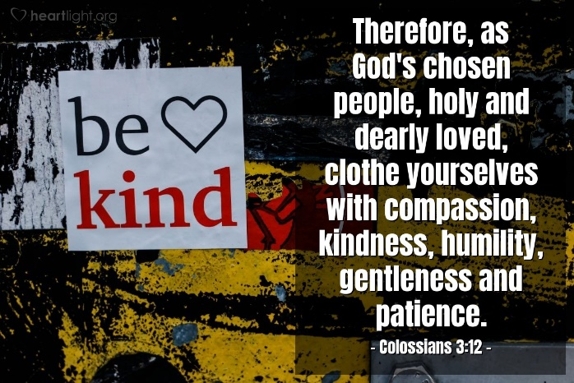

So, put to death the sinful, earthly things lurking within you. Have nothing to do with sexual immorality, impurity, lust, and evil desires. Don’t be greedy, for a greedy person is an idolater, worshiping the things of this world. Because of these sins, the anger of God is coming. You used to do these things when your life was still part of this world. But now is the time to get rid of anger, rage, malicious behavior, slander, and dirty language. Don’t lie to each other, for you have stripped off your old sinful nature and all its wicked deeds. Put on your new nature and be renewed as you learn to know your Creator and become like him.
Since God chose you to be the holy people he loves, you must clothe yourselves with tenderhearted mercy, kindness, humility, gentleness, and patience. Make allowance for each other’s faults and forgive anyone who offends you. Remember, the Lord forgave you, so you must forgive others. Above all, clothe yourselves with love, which binds us all together in perfect harmony.
(As a handout for this message, purchase some individually wrapped candy, preferably something you enjoy too. I like to use Goetz’s Carmel Creams. They are available in most stores, and they are individually wrapped.)
(Make sure you’re holding your Bible in your hand at the beginning of the message.)

Good Morning!
I was reading my Bible this morning. I was reading from the book of Colossians and what the Apostle Paul had to say about what kind of lives we should live as Christians.
One of the many things Paul talks about is being greedy.

Who knows what it means to be greedy? (Wait for Answers)
Imagine you’re at the dinner table, and theirs a bowl of homemade mashed potatoes. There are enough mashed potatoes for everyone in the family. But, your brother or sister scoops all of the potatoes on their plate and eats them all before you can get any. That’s being greedy! Wanting something all for you and not caring about anyone else.
Now, what do you think the opposite of greedy is? (Wait for answers)

The opposite of being greedy is to be generous. It’s showing a willingness to give more of something, such as money or time. It also means showing kindness toward others.
Listen to something important Paul says in the book of Colossians, “you must clothe yourselves with tenderhearted mercy, kindness, humility, gentleness, and patience.”
What does that mean?
When we have a lot of something, we should share it with others. If you have clothes in your closet that you don’t wear or are too small, why not give them to someone who can use them or maybe goodwill.
If you have toys or games that you hardly ever play with, why not share them with kids who don’t have any or very much.
If your family has some extra money, maybe they may want to purchase some groceries and give them to a homeless shelter. Also, Paul is saying we should be kind and caring with other people, especially when they are having troubles in their lives.
You see, it’s easy to be greedy and try and keep a lot of stuff like clothes, toys, and money for yourself. But God doesn’t want us to be like that. He said that’s what the world teaches us, to be greedy. But He wants us to be like His Son Jesus, kind, caring, giving, and loving.

What is something Jesus gave us? That’s right He gave His life on the cross for us because he loved and loves us so much. And, because He did that generous act, we now can have eternal life.

Dear Jesus: Help us to not be greedy. Instead, please help us to be more like you; kind, caring, giving, and generous. Thank you for all you do for us every day.



You know what? My favorite candy is “Goetz’s creme caramels.” When I was young like you guys, we called them bulls-eyes. I bought a couple of bags of Goetz’s yesterday. Now I could have been greedy and kept them at home and ate all of them in the next few days, but I want to be like Jesus, so I’m sharing and going to give one to each of you.
(Handout candy as children return to their seats)



