Children’s Message
Simon Says (Follow Me)
Matthew 4:18-22
“While walking by the Sea of Galilee, he saw two brothers, Simon (who is called Peter) and Andrew his brother, casting a net into the sea, for they were fishermen. And he said to them, “Follow me, and I will make you fishers of men.” Immediately they left their nets and followed him. And going on from there he saw two other brothers, James the son of Zebedee and John, his brother, in the boat with Zebedee, their father, mending their nets, and he called them. Immediately they left the boat and their father and followed him.”

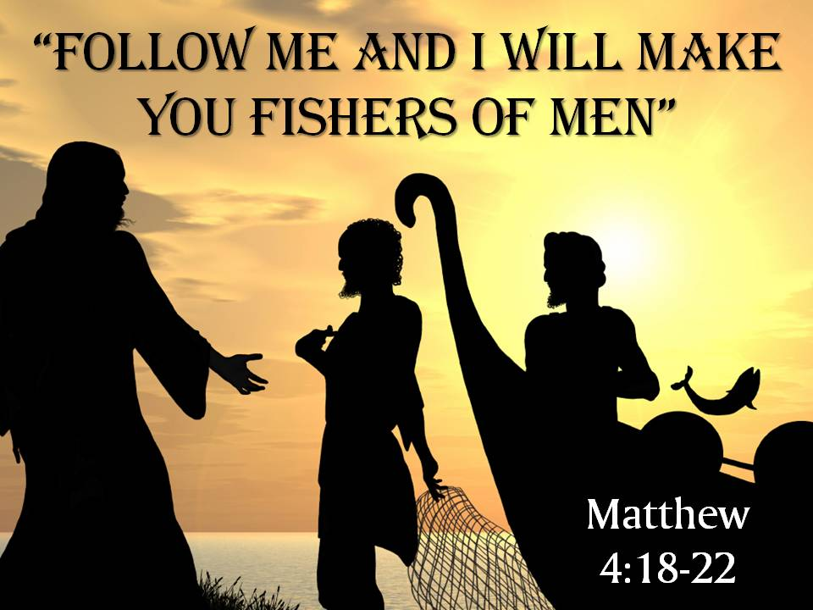
(For this lesson you only need to know how to play Simon Says with the children. It would help if you had a fishing pole with a line and hook, and a small net for visual effect)

Good Morning!
How many of you know how to play the game called Simon Says?
(Answers)
(Explain the game the children)
Is everyone ready to play Simon Says? (Yes)
Let’s begin by everyone standing up. If anyone does something that Simon doesn’t tell you to do, I’ll point to you. If I point at you, sit down.
(Play several rounds of the game, using a few of the ideas in the chart below)
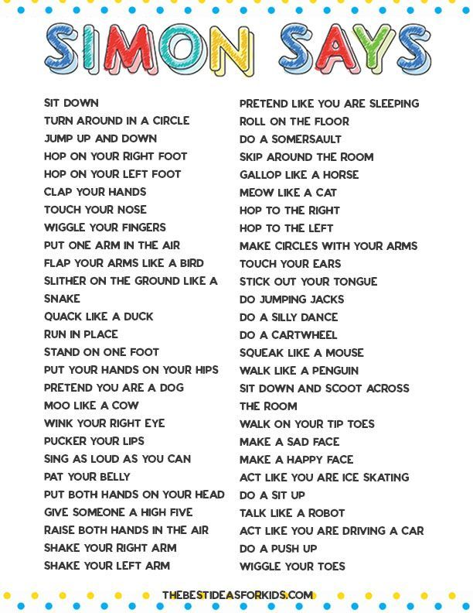
(When you finally have eliminated all but one or two children, declare a winner or a tie)
The Game of Simon Says is a lot like listening to Jesus instead of the world.
The world, who’s kind of like when I don’t say Simon says. The world tells us to follow and do things that aren’t right. Like, it’s okay to only care about money, to buy beautiful and expensive items, to be greedy, and worry only about yourself.
But Jesus, who like Simon in the game, tells us, “Follow Me.” When Jesus first met some of His disciples who were fishing in the Sea of Galilee, He said to them, “Follow me, and I will make you fishers of men.”
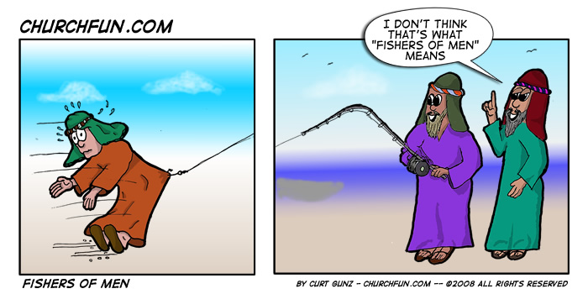
How do you think we can fish for men? Should we get a fishing pole and line with a hook and worm and dangle the worm above people’s heads?
(Wait for answers)
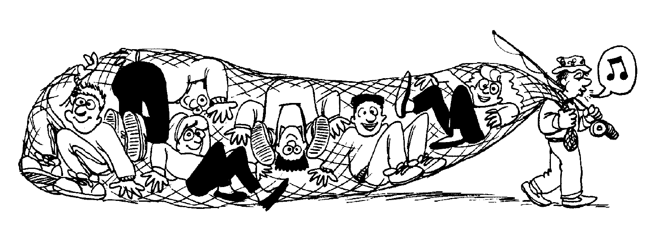
We could get a fishing net like this one (throw it over a child) and catch people that way.
Do you think that would work?
(Wait for answers)
Neither one of those ways will really catch people so they would follow Jesus, will they?
(Answers)
Jesus wants us to follow Him to learn more about what He did, by dying on the cross for us and does in our lives today. He wants to teach us to be more loving to others, to help others, and to be respectful to everyone.
I’ve got an idea, let’s try it right now!
Everyone, please stand up.
Now instead of playing Simon Says, we’ll try a game of Jesus says:
Are you ready?
Jesus says: Say Amen! (Amen)
Jesus says: Jump up and down and be excited.
Jesus Says: Follow (your name) to Sunday school right now and learn more about Me, and there are cookies and juice in your rooms!
(Begin running out of church motioning the children to follow you.) “Hurry up!” “Follow Me,” aren’t you going to listen to what Jesus Says!

