Student/Family Bible study
You are equipped to handle anything

Mark 4:35-41; Luke 9:1-6; Luke 10:1-12; Matthew 6:25-34

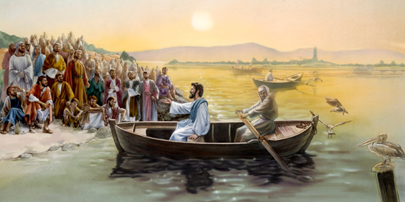

“On that day, when evening had come, he said to them, “Let us go across to the other side.” And leaving the crowd, they took him with them in the boat, just as he was. And other boats were with him. And a great windstorm arose, and the waves were breaking into the boat so that the boat was already filling. But he was in the stern, asleep on the cushion. And they woke him and said to him, “Teacher, do you not care that we are perishing?” And he awoke and rebuked the wind and said to the sea, “Peace! Be still!” And the wind ceased, and there was a great calm. He said to them, “Why are you so afraid? Have you still no faith?” And they were filled with great fear and said to one another, “Who then is this, that even the wind and the sea obey him?”

I don’t like boats. I’ve had a couple of incidents in boats/ships that have made me fear them and going for rides in them.
The first incident was back in 1983. I was working in retail at the time, and I was the grocery manager for Albertson’s Supermarket in Lake Worth, Fl. I won a Progressive Foods contest, and the prize was a trip to the Bahamas for my wife and me.
Unfortunately, I get motion sickness very quickly. I went on the cruise prepared, with a patch on my neck and Dramamine in my pocket. We left on the cruise out of Miami. We barely got out of the dock and into the Gulf stream before the ship began to rock and roll. Within 30 minutes, we were in our room, as was the rest of the travelers on the boat. We were experiencing 20 foot swells, and I was sick, real sick.
I could go on and on about that experience, let’s just say it was terrible. My other incident didn’t directly affect me but had an impact on my mounting dislike of boats.
This time it was a canoe. It was the late 1980’s, and I was a sales manager for a food distributor in Miami. One weekend my fellow sales managers and I decided to go on a canoe trip in Arcadia, FL.
Everything went well until one of the canoes capsized, and the two guys in it lost all their food and drinks. Unfortunately, another thing that happened was that when one of them fell in the water, he gulped some river water down. He ended up with a parasite in his intestines and was hospitalized for a week.

Those experiences stick with you, yet I have always found the story of Jesus calming the storm fascinating for two reasons.
Now, most of you know the story, as told in the bible passages above. Jesus tells His disciples, let’s go to the other side of the lake. After they leave, He lays down on some cushions in the back of the boat and falls asleep after a full day of preaching and teaching. A storm comes up and nearly capsizes the boat. One of the disciples wakes Jesus up, and Jesus tells the wind and waves to stop and be quiet. Jesus then looks at His disciples and says, “Why are you afraid, have you still no faith?”
The two reasons this story fascinates me has nothing to do with the storm per se.
Both items I find fascinating happens before the storm incident.

Item number one – teaching from the boat
Jesus had been teaching from a boat because the crowd that was following Him was so large. So, Jesus taught them while sitting in the boat, while the crowds of people were on the shore. I always found that interesting to visualize in a time when there were no microphones, speakers, or megaphones.
Jesus must have been a very loud speaker when He needed to be, able to throw His voice across the water to the shore so people could hear him.

At some point, Jesus told his disciples, “Let us go over to the other side.”
Here’s the second item that occurs that I find fascinating.

“Leaving the crowd behind, they took him along, just as he was, in the boat.”
The keywords in this passage are, “just as he was in the boat.”
What does that mean to you?
Here’s what I’m hearing when I read that passage. The disciples pulled up the anchor and headed across the lake to the other side. They didn’t go get lunch, or run home to change clothes, Jesus and His disciples, just went.
Now that may not seem like a big deal to you on the surface, but let’s take a moment to read two passages from Luke that expand on the idea of going as you are.


Jesus Sends Out the Twelve Apostles (Luke 9:1-6)
“And he called the twelve together and gave them power and authority over all demons and to cure diseases, and he sent them out to proclaim the kingdom of God and to heal. And he said to them, “Take nothing for your journey, no staff, nor bag, nor bread, nor money; and do not have two tunics. And whatever house you enter, stay there, and from there depart. And wherever they do not receive you, when you leave that town, shake off the dust from your feet as a testimony against them.” And they departed and went through the villages, preaching the Gospel and healing everywhere.”

What did Jesus tell His disciples?
He told them to take nothing for the journey, no staff, no bag, no money, just the clothes on your back.
Why would Jesus tell them that?
Jesus had just equipped them for the journey they were about to go on. He gave them power and authority to drive out demons and to cure diseases. In His mind, they had everything they needed.

Here’s another passage in the very next chapter of Luke.

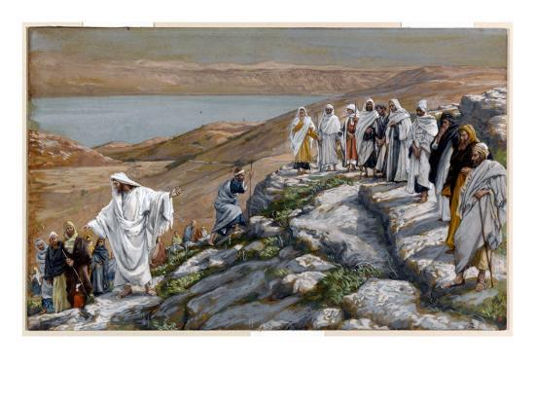
Jesus Sends Out the Seventy-Two (Luke 10:1-12)
After this, the Lord appointed seventy-two others and sent them on ahead of him, two by two, into every town and place where he himself was about to go. And he said to them, “The harvest is plentiful, but the laborers are few. Therefore, pray earnestly to the Lord of the harvest to send out laborers into his harvest. Go your way; behold, I am sending you out as lambs in the midst of wolves. Carry no moneybag, no knapsack, no sandals, and greet no one on the road. Whatever house you enter, first say, ‘Peace be to this house!’ And if a son of peace is there, your peace will rest upon him. But if not, it will return to you. And remain in the same house, eating and drinking what they provide, for the laborer deserves his wages. Do not go from house to house. Whenever you enter a town, and they receive you, eat what is set before you. Heal the sick in it and say to them, ‘The kingdom of God has come near to you.’ But whenever you enter a town and they do not receive you, go into its streets and say, ‘Even the dust of your town that clings to our feet we wipe off against you. Nevertheless, know this, that the kingdom of God has come near.’ I tell you, it will be more bearable on that day for Sodom than for that town.

What did Jesus tell the 72 disciples He was sending out?

Pretty much the same thing He told the 12 disciples He sent out in the previous chapter.
Jesus gave them power, gave them thorough instructions on how they should handle themselves as they went about His business.
Did He ever mention food, clothing, or a specific place to stay?
Not really. Jesus said if you go into a town and they receive you “kindly” eat what they put before you if they don’t welcome you “kindly” walk away and move on. There are plenty of people out there that will listen to the Gospel message.

What does Jesus mean by this?

Let’s look at one more verse in the book of Matthew.

Do Not Be Anxious (Matthew 6:25-34)
“Therefore, I tell you, do not be anxious about your life, what you will eat or what you will drink, nor about your body, what you will put on. Is not life more than food and the body more than clothing? Look at the birds of the air: they neither sow nor reap nor gather into barns, and yet your heavenly Father feeds them. Are you not of more value than they? And which of you by being anxious can add a single hour to his span of life? And why are you anxious about clothing? Consider the lilies of the field, how they grow: they neither toil nor spin, yet I tell you, even Solomon in all his glory was not arrayed like one of these. But if God so clothes the grass of the field, which today is alive, and tomorrow is thrown into the oven, will he not much more clothe you, O you of little faith? Therefore, do not be anxious, saying, ‘What shall we eat?’ or ‘What shall we drink?’ or ‘What shall we wear?’ For the Gentiles seek, after all these things, and your heavenly Father knows that you need them all. But seek first the kingdom of God and his righteousness, and all these things will be added to you.
“Therefore, do not be anxious about tomorrow, for tomorrow will be anxious for itself. Sufficient for the day is its own trouble.”

Do you see where I’m going with this?
Jesus sent the 12 and 72 out equipped with everything they needed, and when He crossed the lake with His disciples with no food or supplies, He knew they had everything they needed.
What did the disciples in the boat have that they needed?

THEY HAD JESUS!
That’s all they needed. In all three cases, Jesus wasn’t worried about food, or where they would sleep. He knew that was going to be taken care of.
He does the same for us today. He tells us, do not worry. He’s got things under control, even when we ride into a storm, and we feel there’s no hope.
Here’s the point!
When Jesus tells us to “Go,” we need to go. When the Holy Spirit whispers to us and leads us to someone He wants us to share the Gospel with, we need to do it.
Don’t worry that you may be rejected. What did Jesus tell His disciples? Shake the dust from your feet and move on. There are a lot of people in this world that need to hear the Good News of the Gospel. You and I are Christ’s hands and feet.
“Go and make disciples of all nations …”


Lord, help us to be prepared to follow you and go where you tell us, talk to who you want us to, without hesitation or reluctance. Help us to share your Gospel story with all who will listen.



