Devotion
The Son becomes the Father

I am a superhero fan.
I love all of the Marvel superhero movies that have come out in the last twelve years. Ironman, Thor, Captain America, Hulk, Dr. Strange, etc.
Yet, being an old-timer :) I'm still a throwback to the superhero who celebrated his 82nd birthday this year.
Superman!
When I was a kid, I watched the Superman TV show every Saturday morning. And when the movie came out in 1977, I saw it at the theater, wait for it, twenty-two times!

One of my favorite lines from the movie (and it was repeated on the Supergirl TV show the other night) is, "The son becomes the Father, and the father becomes the Son."

There are times in our lives when we have a role reversal, sometimes even permanently, with a parent.
In recent years I've had several occasions when my daughter Heather (who turned 32 yesterday) has been the smarter one in the room or followed through for me on something when I wasn't able to.
And there are times when a child must assume the permanent role of adult for their parent due to age, illness, dementia, or even Alzheimer’s.

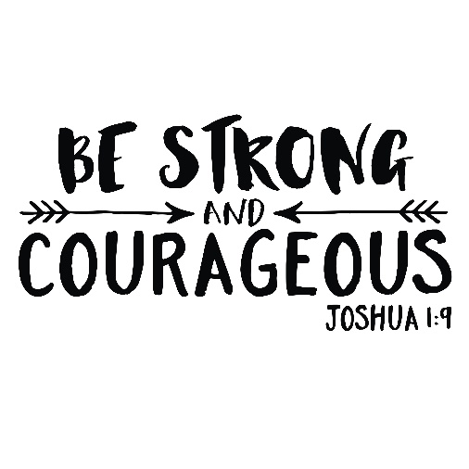
In the Old Testament, Moses was the father figure for Joshua. He treated him like a son and trained him to one day assume the leadership of the Hebrew nation.

In Deuteronomy 31:6, Moses is turning the leadership of the Hebrew nation over to Joshua because he knows that he will not be entering the Promised Land. Moses tells Joshua to "Be strong and courageous" and that the Lord will be with him wherever he goes.
Those words must have struck a chord with Joshua because he repeats them to his army almost verbatim in Joshua 1:9.

What words from your parents carry over into your life? Even more importantly, what words of God/Jesus do you carry on from our heavenly Father to your children or other family members?

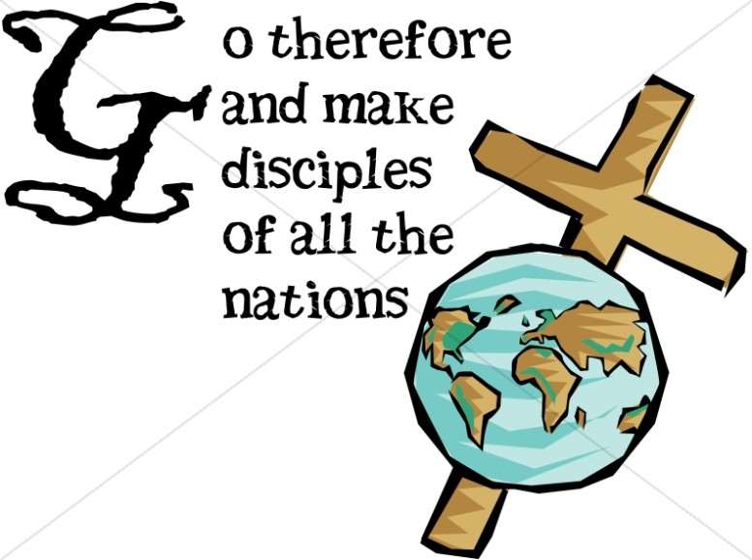

I have many favorite bible passages. Let me share one that was passed on to me by my Pastor (Dr. Mark Behring) many years ago (a father figure for me), that I have shared with hundreds of students and my family throughout the years.

"Go therefore and make disciple of all nations, baptizing them, in the name of the Father and of the Son and the Holy Spirit, ' teaching them to observe all that I have commanded you. And behold' I am with you always, to the end of the age."

Do you see the consistency of God's Word here? Jesus is telling us to “Go” and make disciples, and He promises that, “I am with you always, to the end of the age.”
Joshua told his army to, “Be strong and courageous; I am with you wherever you go!”

The Son is passing on the Father's promise to His people.
What biblical words of wisdom will you pass on to your children?
“For God so loved the world?”
“I can do all this through him who gives me strength?”

It’s worth it to take some time to write down passages that are important to you to pass on to others. Take some time to do just that.



“Father, your words in the bible are so important. Help us to pass on the importance of your Word, plus passages that are important to us that we can share with our families, friends, and others.”
Amen

Have a Blessed Day

God is good all the time, all the time, God is good.
Joe G

