Devotion
Let the little children come to me
Matthew 19:13-15
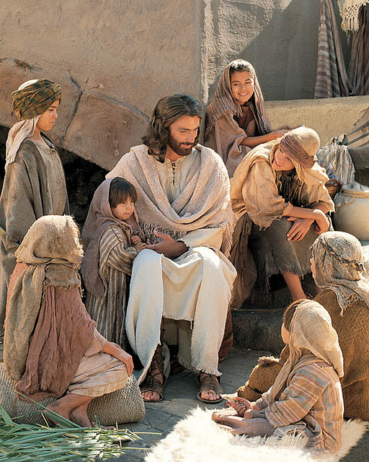

"Then, people brought little children to Jesus for him to place his hands on them and pray for them. But the disciples rebuked them.
Jesus said, "Let the little children come to me, and do not hinder them, for the kingdom of heaven belongs to such as these." When he had placed his hands on them, he went on from there."

There's nothing quite like a kind or loving touch from another person, is there?
A boy and girl or man and woman holding hands as they walk through the mall, people are holding hands as they pray at the dinner table, a hug from your child or grandchild, or touching the one you love on the cheek as you look into their eyes.

Jesus was a loving touch person. He touched people, and they were healed. The blind man, the woman who touched His robe were healed, and He touched His disciple's feet as He washed them, showing them how to serve one another.
In the book of Matthew 19:13-15, parents were looking for Jesus to touch their children and to pray for them. Now it doesn't say why they wanted Him to touch them, but it can be presumed it was for a blessing and or general healing. (Luke's Gospel says explicitly that the children were babies.)
Yet the disciples tried to send these families away until Jesus intervened and rebuked them. He made it a teaching moment that went beyond touching.

Jesus said, "Let the little children come to me and do not hinder them, for to such belongs the kingdom of heaven.
First of all, Jesus admonishes His disciples when He says, "Let the children come to me and do not hinder them." Yes, they are children but don't you ever stop them from coming to me. Second, He says, "For to such belongs the kingdom of heaven."

What is Jesus talking about in the statement above? It's this. There is only one required standard to enter the kingdom of heaven, and that is to have childlike faith in Christ.
Children don't have what we do have, and we need not have to enter the kingdom. Now there's a sentence for you :)

You see, children are meek, they don't have malice, they have no pride, and they aren't ambitious. Children don't care about how much money you make, and they don't judge people. They care about others better than most adults, and in their eyes, everyone is their friend.
God wants us to get rid of all our stinginess, all of our jealousies, any malice we may have towards others, and instead possess that innocent, childlike faith of a little child. God wants our unconditional love. He wants us to believe in what His Son Jesus accomplished by dying on the cross. And He wants us to serve all of humankind.

Sounds easy, doesn't it? We all know that is not true. Yet it is something we should strive for every day, to love Jesus with all of our heart, mind, and soul, like that of a little child.
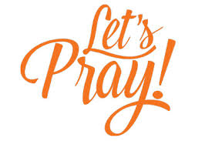
Dear Lord, help us to keep our minds and hearts open and innocent as that of a child’s.
We want to love you unconditionally, and we want to believe in your Son Jesus and what he did on the cross for us.
But, sometimes our faith is weak. Help our faith in you, your Son, and the Holy Spirit grow each day. Help us to be closer to you and have Faith, so we can live with you in eternity.
Amen

