Children’s Message
“Living Water”
John 4:4-14
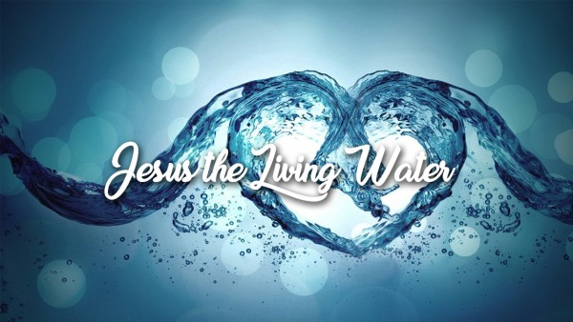
“He had to go through Samaria on the way. Eventually, he came to the Samaritan village of Sychar, near the field that Jacob gave to his son Joseph. Jacob’s well was there, and Jesus, tired from the long walk, sat wearily beside the well about noontime. Soon a Samaritan woman came to draw water, and Jesus said to her, “Please give me a drink.” He was alone at the time because his disciples had gone into the village to buy some food.
The woman was surprised, for Jews refuse to have anything to do with Samaritans. She said to Jesus, “You are a Jew, and I am a Samaritan woman. Why are you asking me for a drink?”
Jesus replied, “If you only knew the gift God has for you and who you are speaking to, you would ask me, and I would give you living water.”
“But sir, you don’t have a rope or a bucket,” she said, “and this well is very deep. Where would you get this living water? And besides, do you think you’re greater than our ancestor Jacob, who gave us this well? How can you offer better water than he and his sons and his animals enjoyed?”
Jesus replied, “Anyone who drinks this water will soon become thirsty again. But those who drink the water I give will never be thirsty again. It becomes a fresh, bubbling spring within them, giving them eternal life.”

(For this Message, have a glass of ice water, a glass or small carton of milk, a couple of cookies, and a can of soda ready.)
(An appropriate hand out for this message would be small bottles of cold water for each child – and don’t forget small packages or bags of cookies)
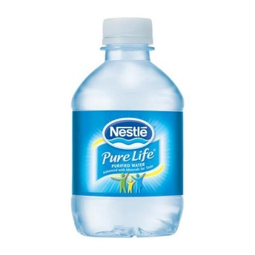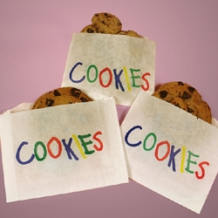

Good morning!
(Take a drink of the water)
MMMMMM Ice cold thirst-quenching water!
How many of you drink a lot of water? (Wait for a show of hands)
How much water do you drink each day? (Wait for answers)
Do you know, many health experts say we should drink 8 glasses of water a day? And if you are playing hard or working hard and sweating a lot, you may need even more water.
Of course, there are other things to drink besides water, like milk.
How many of you drink milk? I love to drink a nice cold glass of milk while I’m eating some cookies, mmm mmm, good!
Oh, and sometimes I’ll drink a soda, especially if I’m eating a hamburger and fries. But there’s nothing like a cold glass of water when you’re thirsty.
The part of the world where Jesus lived was scorching hot and dry. One day he was traveling through an area called Samaria. While Jesus was in Samaria, he passed through a small village called Sychar.
Jesus was hot, tired, and thirsty, and so He sat down by a well. It was just about lunchtime when a woman who was a Samaritan came to the well to fill her water jar. Jesus looked at the woman and said, “Please give me a drink.”
The woman was shocked. You see, in those days, Jews wouldn’t be caught dead talking to a Samaritan, because they didn’t like each other very much.
The woman asked Jesus, “Why are you, a Jew, asking me a Samaritan woman for a drink?”
Jesus said, “If you knew who it is who is asking you for a drink, you would ask him for a drink, and he would give you living water. Everyone who drinks from this well will be thirsty again, but whoever drinks the water that I give will never thirst.”
Have any of you ever seen living water?
When I was about your age, my parents would take to Wisconsin on vacation to the Wisconsin Dells. And we used to go to Tommy Bartlett’s dancing water show at night. The waters would look like they were alive and dancing with music playing and all sorts of fountains and colorful lights.
Do you think that’s the kind of water Jesus was talking about when he said, “Living Water?”
You see, the Living Water Jesus is talking about in the story is our Faith in Jesus and that water is inside of us. It’s our Faith that Jesus Christ is our Savior and the Savior of the whole world, and because of Jesus’ sacrifice on the cross, we have eternal life.
(Grab the glass of water again)
MMMMMM, ice-cold thirst-quenching water. It refreshes the body, but it can’t compare to the “Living Water” that Jesus gives us, because it refreshes our soul!

Repeat after me:
Dear Jesus: You are our living water because we have faith in you. We believe that you died on the cross for our sins, and because of that, we will someday have eternal life with you. You will always be living water in our lives.

(Hand out a bottle of water and cookies to each child as they return to their seats)
(Coloring pages available on next page, or online)

