Children’s Message
“Do you know your address?”
Luke 6:12-16
(For this message, you’ll need either a whiteboard or newsprint on an easel, plus some colored markers. You may want to write out the 52 MAB ST vertically on your board in advance, but keep it covered until you’re ready to teach the children the Apostle’s names.))
(As a handout for the children, give them a card with the 52 MAB ST information listed as you see below in the message, as well as the Bible verses, so they can do memory work with their parents to remember the names of the Apostles.)

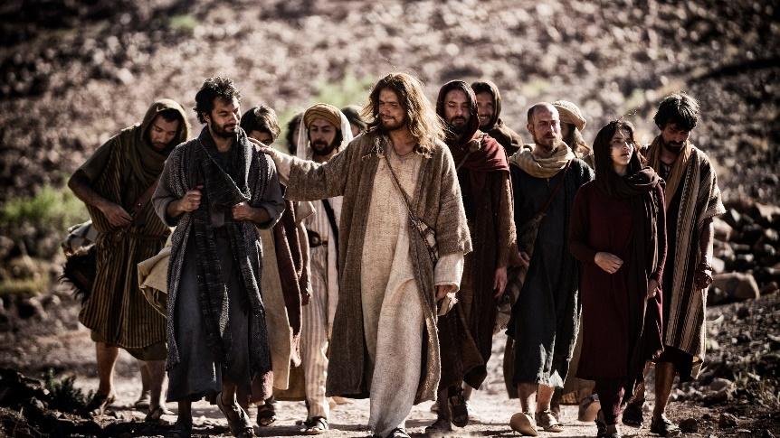

“In these days he went out to the mountain to pray, and all night he continued in prayer to God. And when day came, he called his disciples and chose from them twelve, whom he named apostles: Simon, whom he named Peter, and Andrew his brother, and James and John, and Philip, and Bartholomew, and Matthew, and Thomas, and James the son of Alphaeus, and Simon who was called the Zealot, and Judas the son of James, and Judas Iscariot, who became a traitor.”

Good Morning!
I want to start off this morning by asking all of you a question? Raise your hand if you know what your address is?
(Allow children to say their addresses aloud if they know them, just their address, not city and zip code.)
Very good! Most of you know your address. Why is it important to know what your address is?
(Wait for answers from the children)
Good job! We need to know our address for a lot of reasons. If we invite someone over to our house, would they find our home if we told them we lived in a city like Cocoa Beach, FL? (Responses)
Would you ever receive mail at your house if you didn’t have an address? (Answers)
Could you get the newspaper delivered to your home if you didn’t have an address? (Answers)
So, our home addresses are very important.
I have a very special address I want to talk to you about today. (Show the children the board with the address, minus the names). What is the address I have written up here on the board? (Responses)
That’s right 52 MAB ST
I don’t believe 52 MAB ST is a real address, but there is a song about the address.
This address can help you remember a very important bible passage in the book of Luke.

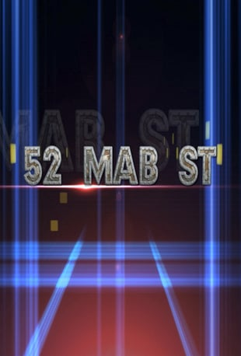

Those 12 Apostles. What were their names again?
52 MAB ST is a fun way to learn to memorize the names of Jesus’ 12 Apostles

5
2
M
A
B
S
T
(Read the Bible verses out loud)
Here’s what the bible verses I just read tell us. There are 5 Apostles whose name starts with the letter J. (Write them out) Two of the Apostles names begin with the letter P. (Write them out) All the rest of the letters in 52 MAB ST are the first letters of the names of the remaining Apostles.
(Go over the names one by one, telling the children little tidbits of information. Matthew was a Tax Collector, Thomas is known as doubting Thomas, Jesus left Peter in charge before He went back to heaven, and Judas Iscariot is the Apostle who betrayed Jesus.)
5 John, James, James, Judas, Judas
2 Phillip, Peter
Matthew
Andrew
Bartholomew
Simon
Thomas
I like to call 52 MAB ST, the Apostles address. It’s essential to know the names of the Apostles. These were the men Jesus lived with and taught for three years. Even though Peter was left in charge, Jesus left all of the Apostles in charge of bringing the Word of God to the world, as well as the fact that Jesus died on the cross for our sins.
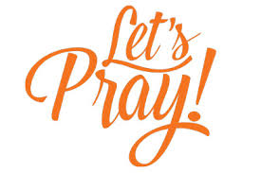

Dear Jesus, thank you for leaving your 12 Apostles to teach, preach, and spread the word of your Gospel Message, telling the world that you died for us and they can be saved by having Faith in You.
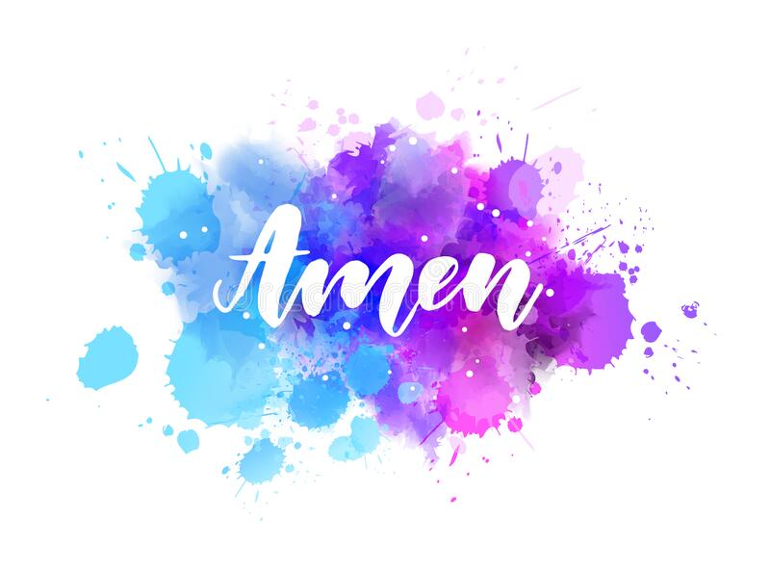

(As children go back to their seats give them a card with 52 MAB ST and the Apostles names on it so they can work on memorizing them with their family)
