Children’s Message
The Holy Trinity
John 3:1-17; John 16:12-15
(Here are three different items you can do to introduce the idea of three in one, or trinity. First, purchase a small can of 3 in 1 oil …

you’ll notice the label it says: “Lubricates, Cleans & Prevents Rust.” Thus, it follows the dictionary definition of Trinity, “a group of three people or things.”

The second item would be to have three eggs, still in the shell or cracked open as in the photo above, sitting in a bowl. Again, you have a group of three things, and they are in one container. Then take a whisk and mix the eggs together; now you have three eggs that are one.


The third item to use would be this photo of the three in one Trinity as you are describing each separate part of the Trinity.)
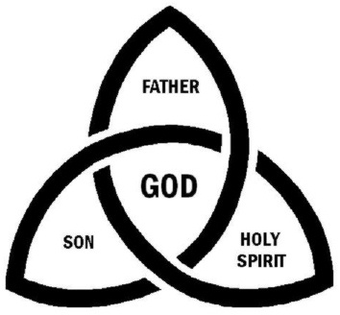

(Finally, as a hand out give each child a bite-sized Three Musketeers Bar. They, too, are a group of three people.)
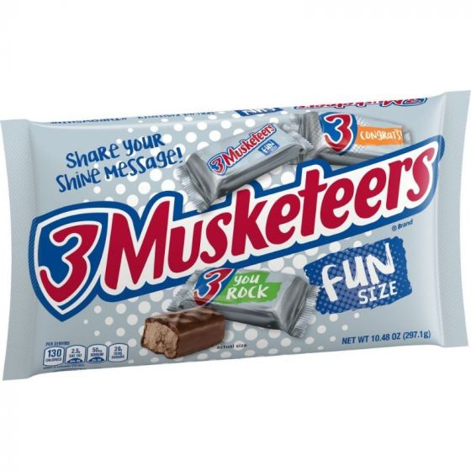

Good Morning!
Does anyone know what day we’re celebrating at church today? (Answers)
That’s right, it’s Trinity Sunday. Who knows what the word trinity means? (Answers)
In the dictionary, the definition of the word trinity is a group of three people or things.
Let me give you a few examples: Here’s a can of a famous oil that many of your families probably have at home. It’s called 3 in 1 oil. On the label of the can, it says that this oil, Lubricates, Cleans & Prevents Rust. So, this can has a group of three things it does in one oil.
Here’s another example: Here’s a bowl with how many eggs in it? (Answers) that’s right; there are three eggs in the bowl. So, you might say I have three in one. Because there are three eggs in one bowl.
What happens if I take this whisk (Hold it up) and mix the eggs up? Let’s see. (Whisk the eggs together). What happened? (Answers) Now we have three eggs that are one.
That brings me to my final 3 in one.
Who can tell me what this is? (Show a picture of the Trinity photo above). (Answers)
This is a picture of what Trinity Sunday is all about.
(Point to the center of the picture) Who’s name is this in the middle? (Answers) That’s right, it’s God. But, our God is very special, He is one God, but He’s also three persons.
That’s kind of hard to understand, so let’s look at each one.
On the top, we have God the Father. Who can tell me what God the Father did? (Answers) He created everything. He created the world, the oceans, the land, the stars, the sun, and the moon, all the animals and fish, and He created who? (Answers) Men and women.
So that’s part of what God the Father did. He did something else too. He sent us His Son Jesus. God, the Son. What did Jesus do? (Answers)
Jesus was born in a manger, became a teacher, He preached, told stories, healed sick people, raised people from the dead, and did so many other miracles.
Who can tell me what happened to Jesus? (Answers) That’s right He died on the cross for our sins, and then God the Father raised Him from the dead after just three days. Then He ascended (which means He went up) to heaven.
So that’s God the Father and God the Son. But there’s one more up here on this sheet isn’t there. That’s right, it’s God the Holy Spirit.
Jesus promised that he would send the Holy Spirit, and He did just that. Remember last week’s message about Pentecost? The Holy Spirit came down and appeared to the disciples like tongues of fire upon their heads.
The Holy Spirit has a very important place in our lives too. Because He lives (point to your heart) right here. After we are baptized, the Holy Spirit enters our hearts and lives within us our whole life. He fills us with love for others. The Holy Spirit is our guide and tells us when we’re doing something wrong. He also helps up to be loving and kind to others. Finally, the Holy Spirit encourages us to read and learn God’s word in the bible.
God the Father who created the world, God the Son who saved us from sin, and God the Holy Spirit always teaching us and guiding us.
Three people, one God. The Blessed Trinity.
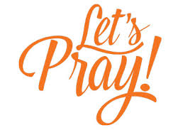
Dear Father, Son, and Holy Spirit: Thank you for being such an amazing God. You created everything; you saved us from sin, and you live in our hearts as a teacher and guide. We love all of you, the 3 in one.
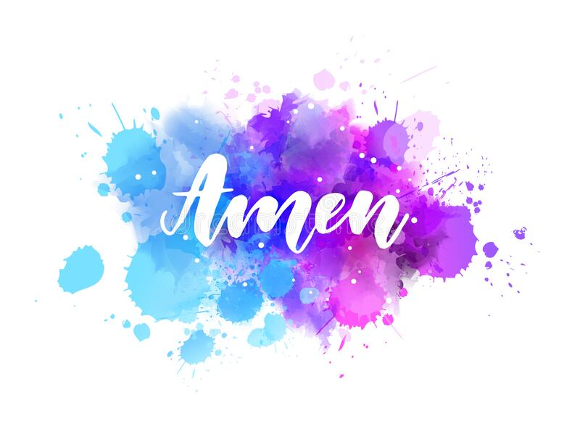

(Hand out candy bars – with explanation)

