Pentecost
Children’s Message
The God that keeps on giving
Isaiah 9:6-7a; Luke 2:4-7; Acts 2:1-4 (ESV)

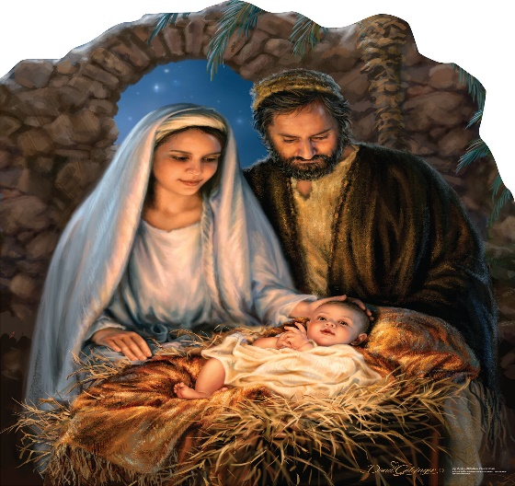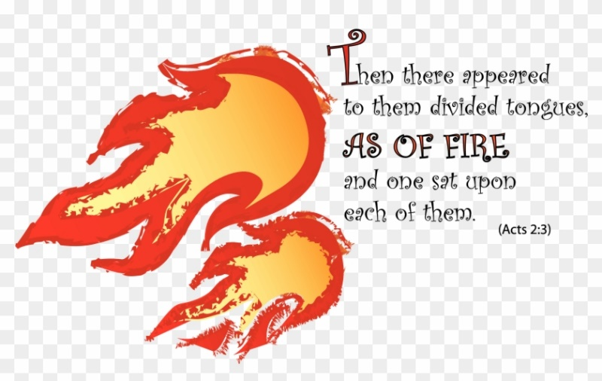

(For this message, you’ll need two small wrapped boxes with a picture gift in each. The first box should be wrapped in Christmas paper and have a picture of Jesus in it. (You can also attach a note that says, “Merry Christmas). The second should be wrapped in a nice shiny paper if you have it, or Christian wrapping paper and have a picture of tongues of fire … feel free to copy the one above. (You can also attach a notecard that says, “Have a Blessed Pentecost.”)
(As a handout give the children a Dove chocolate, to remind them how the Holy Spirit entered them through the water and Word at their Baptism)
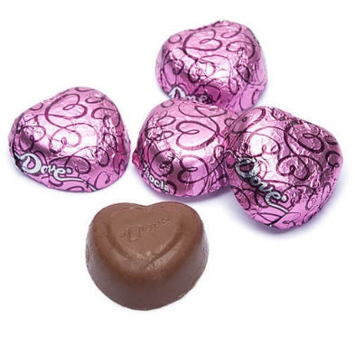
Good Morning!

(Show the Christmas Gift and card)
What does this look like to you? That’s right; it seems to be a Christmas gift to me too? Can one of you help me open it, so we can see what’s inside? (Pick a child to open the present.)
What’s inside of the package? (Answers) That’s right; it’s a picture of Jesus. That’s interesting, and the card that was attached to the gift says, “Merry Christmas.”
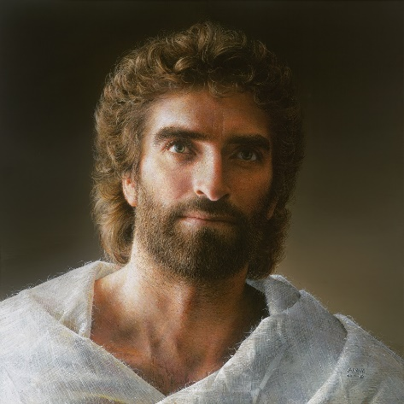
Why do you think the gift box had a picture of Jesus in it? (Answers) That’s right because Jesus was born on Christmas day. God sent Jesus as a gift to every man, woman, and child.
What did Jesus do for us? (Answers) That’s right. He died on the cross for our sins. He also taught us a lot of things, like how we should be kind and loving, and to be a servant to others. That means we should help others who are in need.
Jesus was and is the best Christmas gift anyone could ever get! (Pause)
Hold on a second. I have another box here.
(Show the Pentecost gift and card)
Does anyone know what might be in this box? (Answers)
The wrapping paper is shiny, and there are some Christian symbols on it. Who would like to Help me open this gift? (Choose a child)
There’s a picture inside of this box too. What do you think this is a picture of?
(Answers)
Well, this is a picture of tongues of fire, and the card says, “Have a Blessed Pentecost.” Does anyone know what Pentecost is? (Answers)
Pentecost is the day that God sent the Holy Spirit to live in Jesus’ disciples after He had gone back to heaven.
Here’s what the Bible says, In the book of Acts, “When the day of Pentecost arrived, they were all together in one place. And suddenly there came from heaven a sound like a mighty rushing wind, and it filled the entire house where they were sitting. And divided tongues as of fire appeared to them and rested on each one of them. And they were all filled with the Holy Spirit and began to speak in other tongues as the Spirit gave them utterance.”
Here were the disciples sitting in a room waiting like Jesus had told them to do. And suddenly, bam, God sent the gift of the Holy Spirit to them. And the first thing that happened was that they went outside and began speaking to people about Jesus. And even if the people only spoke and understood a different language, they were able to understand what the disciples were saying.
Who thinks it would be cool if the Holy Spirit came down right now and sat on the top of your head like a little flame without burning you? (Raise your hand)
Guess what? We don’t have to look for a little flame on our heads, because if we’re baptized (point to the baptismal font) then we have the Holy Spirit living in us. Just as the Holy Spirit came down upon Jesus like a dove when He was baptized by John the Baptist.
Wait a minute (Go up to one of the children), could you open your mouth, please? (Look in their mouth). Hmmm, wait a minute (Go up to another child), can I look in your ears, please. (Look in their ears.)
I looked in your ears, and your mouth, and all I saw was your tongue and some ear wax. The was no sign of the Holy Spirit.
That’s because God sent His Holy Spirit to live in our hearts and soul. And the Holy Spirit helps us during our whole life. He whispers to us when we may be getting ready to do something wrong, He helps us to do better and make good choices, and He helps us stay on the life path that God wants us to follow.
God is pretty cool, isn’t He? God sent us Jesus at Christmas to live with us and die on the cross for us, and on Pentecost, He sent His Holy Spirit to live within us as guide and helper for our whole life.
God is a pretty good gift-giver, isn’t He?
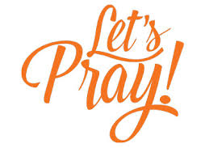
(Pray and echo prayer, where the children repeat what you say)
Heavenly Father: Thank you for the many gifts you give us. When we were born, you gave us the gift of life. At Christmas, you gave us your Son Jesus, and at Pentecost, you gave us the Holy Spirit. Lord, You are the best gift-giver ever.


(Hand out Dove chocolates)

