Children's Message
You Don't Have to Worry
Matthew 6:25-34
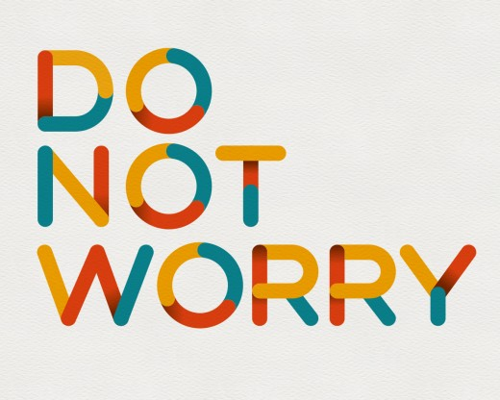
"Therefore, I tell you, do not worry about your life, what you will eat or drink; or about your body, what you will wear. Is not life more than food and the body more than clothes? Look at the birds of the air; they do not sow or reap or store away in barns, and yet your heavenly Father feeds them. Are you not much more valuable than they? Can any one of you by worrying add a single hour to your life6:27 Or single cubit to your height?
"And why do you worry about clothes? See how the flowers of the field grow. They do not labor or spin. Yet I tell you that not even Solomon in all his splendor was dressed like one of these. If that is how God clothes the grass of the field, which is here today, and tomorrow is thrown into the fire, will he not much more clothe you—you of little Faith? So, do not worry, saying, 'What shall we eat?' or 'What shall we drink?' or 'What shall we wear?' For the pagans run after all these things, and your heavenly Father knows that you need them. But seek first his kingdom and his righteousness, and all these things will be given to you as well. Therefore, do not worry about tomorrow, for tomorrow will worry about itself. Each day has enough trouble of its own."


(For this message, you'll need two paper plate masks. One should have a happy face on it, and the other a sad face. You can mount them on the ends of craft sticks so two volunteer children can hold them in front of their faces when you ask them to.)

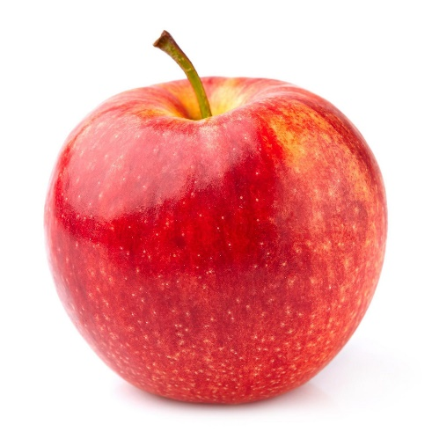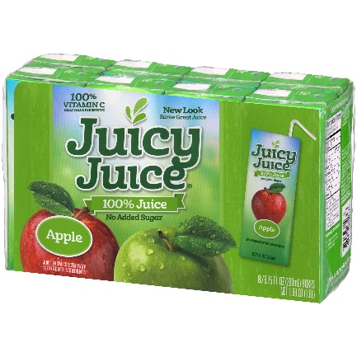

(As a handout for the children have an apple and a juice pack ready for each of them. At the end of the message, after the prayer, you can tell them remember Jesus said not to worry about what you will eat or drink. Here's something for each of you to eat and drink, now you don't have to worry about hungry or thirsty!)

Good morning!
When my daughter was a baby, she would cry a lot when we went for a drive in our car. We tried talking to her, giving her toys, and sometimes my wife would sit in the backseat with her.
Those things all helped to get her to stop crying a little bit, but we found one thing that worked the best to quiet my daughter down. It was a song. The name of the song was, "Don't worry, be happy." The song went like this, (at this point you could have the song downloaded from YouTube and play the first verse, https://www.youtube.com/watch?v=d-diB65scQU
(I always find playing a song during a message awkward), or you can say or sing the 1st verse below),
"Here's a little song I wrote
You might want to sing it note for note
Don't worry, be happy
In every life, we have some trouble
But when you worry you make it double
Don't worry, be happy
Don't worry, be happy now."

Raise your hands if you have ever worried about something? What are some things that make you worry? (Point to children and let them answer the questions.)
What kind of face do you make if you're worried about something? (Have the first volunteer put the sad faceplate in front of their face.)
That's right. It’s kind of a sad face, isn't it? We all worry about so many things. Kids worry about getting good grades in school, parents worry about having enough money to take care of their families. Sometimes, we worry about getting sick, and other times we worry about where we'll get our next meal or even clothes to wear.
In chapter six of the book of Matthew, Jesus says, "Do not worry!" Jesus says, don't worry about where you'll get food or clothes. I'll take care of that. He says what's more important is to seek the kingdom of God.
How do we seek the kingdom of God? (Wait for answers)
That's right. We go to church, Sunday school, read the bible, and do the things that Jesus did, like serve others. Most of all, it's essential for us to have Faith. That means believing in Jesus and that He died on the cross for our sins.
Here's another question for you. If Jesus says, don't worry, and we know and believe that He is the Son of God, and we believe that He will take care of us: what kind of face should we have? This sad face over here, or (Have the child with happy faceplate, raise their plate in front of their face), a happy face like this one?
That's right! The happy face. Jesus says, "Don't worry!"
Do you know what I say? "Don't worry, be happy!"

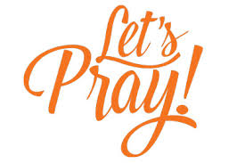

Dear Jesus: Help us not to worry about things like food, clothing, or what may happen tomorrow. We believe that you will always take care of us even when things in our life get complicated. Thanks for loving us so much that you were willing to die for us. We love you.

(Hand out the juice packs and apples to the children)

