Youth/Student Devotion – 1/6/2020
The Lost Son – Luke 15:11-32 (NIV)
(Open your devotion time in prayer)

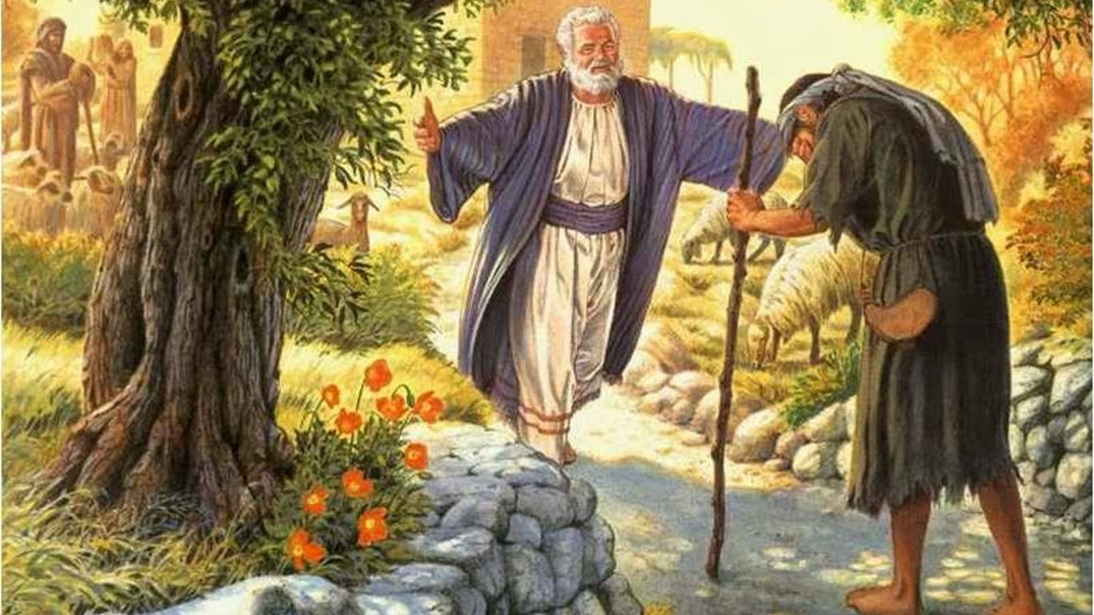

(Have one or two of your students read the Bible passage aloud as the others follow in their bibles.)
Jesus continued: “There was a man who had two sons. The younger one said to his father, ‘Father, give me my share of the estate.’ So he divided his property between them.
“Not long after that, the younger son got together all he had, set off for a distant country and there squandered his wealth in wild living. After he had spent everything, there was a severe famine in that whole country, and he began to be in need. So he went and hired himself out to a citizen of that country, who sent him to his fields to feed pigs. He longed to fill his stomach with the pods that the pigs were eating, but no one gave him anything.
“When he came to his senses, he said, ‘How many of my father’s hired servants have food to spare, and here I am starving to death! I will set out and go back to my father and say to him: Father, I have sinned against heaven and against you. I am no longer worthy to be called your son; make me like one of your hired servants.’ So he got up and went to his father.
“But while he was still a long way off, his father saw him and was filled with compassion for him; he ran to his son, threw his arms around him and kissed him.
“The son said to him, ‘Father, I have sinned against heaven and against you. I am no longer worthy to be called your son.’
“But the father said to his servants, ‘Quick! Bring the best robe and put it on him. Put a ring on his finger and sandals on his feet. Bring the fattened calf and kill it. Let’s have a feast and celebrate. For this son of mine was dead and is alive again; he was lost and is found.’ So they began to celebrate.
“Meanwhile, the older son was in the field. When he came near the house, he heard music and dancing. So he called one of the servants and asked him what was going on. ‘Your brother has come,’ he replied, ‘and your father has killed the fattened calf because he has him back safe and sound.’
“The older brother became angry and refused to go in. So his father went out and pleaded with him. But he answered his father, ‘Look! All these years I’ve been slaving for you and never disobeyed your orders. Yet you never gave me even a young goat so I could celebrate with my friends. But when this son of yours who has squandered your property with prostitutes comes home, you kill the fattened calf for him!’
“‘My son,’ the father said, ‘you are always with me, and everything I have is yours. But we had to celebrate and be glad because this brother of yours was dead and is alive again; he was lost and is found.’ ”

Many of you have heard this bible story many times before in church or during other Bible studies. I’d like everyone to take a couple of minutes to re-read the passage to yourself this time. As you read, I’d like you to focus in on several things. First, look at the big picture. Who is the Young Son’s Father, and who is the Young son, if you were to take this story and make it “real” world, right now?
Second, since this is the season of Epiphany, what was the Young Son’s Epiphany?
Third, why was the Father so welcoming after all the things his youngest son had done?
Fourth, what was the older brother’s problem? Why did he have such an attitude?
And finally, fifth, who do you relate to more, the lost son or the older brother? Why?
(After the students have re-read the passage and taken a few minutes to think about the questions, review the questions and their answers. In most cases, there isn’t a really wrong answer because each one of them will perceive the question or the person and the situation differently. Give your own thoughts on each question after it has been discussed. Here are some of my ideas that you may or may not use at your discretion.)

One of the exciting things about this passage is that the father is actually the main character of the story, not the lost son. The father is the one who gives his young son his inheritance early (free will). It’s the father who is even more lavish than the lifestyle the young son had been living. When he sees his son, he doesn’t listen to his whole story; instead, the father calls for his servants to give his young son a robe, jewelry, shoes, and to throw a feast in honor of his return.
Then the father who is obviously a rich man goes out to his oldest son and asks him repeatedly to come inside the house and celebrate the return of his brother. Unfortunately, it seems the brother wants nothing to do with this party.
This is a story of forgiveness, of redemption as, well as a jab at the pious religious leaders of the time (the older brother.)
The father allowed the son to use his free will to live the life he saw fit. When the young son came back in humility, the father forgave him and threw a party for him.
It’s not unlike the story of the lost sheep is it, “Suppose one of you has a hundred sheep and loses one of them. Doesn’t he leave the ninety-nine in the open country and go after the lost sheep until he finds it? And when he finds it, he joyfully puts it on his shoulders and goes home. Then he calls his friends and neighbors together and says, ‘Rejoice with me; I have found my lost sheep. ’I tell you that in the same way there will be more rejoicing in heaven over one sinner who repents than over ninety-nine righteous persons who do not need to repent.
It’s the same for you and me. Although God’s Holy Spirit has a path for us to follow throughout our lives, we sometimes stray off that path or even leave it altogether. Yet, when any one of us returns to that path, to the Lord, for forgiveness. All of heaven is overjoyed. We are forgiven when we mess up, just like the young son. Jesus died for our sins, we are forgiven every time we mess up. Jesus’ loving arms are always open and ready to welcome us back to the fold.

(Close your devotion time with a prayer.)

