Red Letter Youth/Student Bible Study – November 5, 2019
The address of the twelve Apostles: 52 MAB ST – Luke 6:12-16
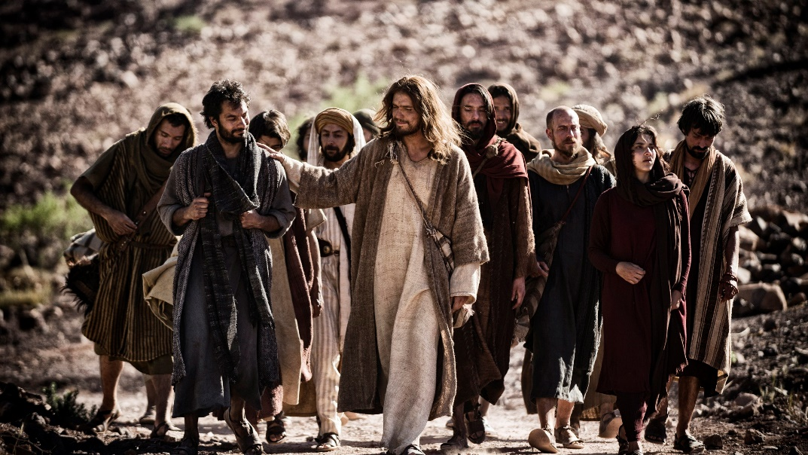
(Begin your worship time with the students joining together in saying the opening blessing aloud, and making the sign of the cross)
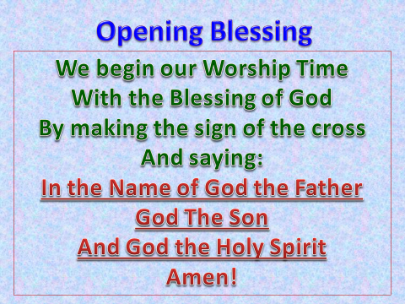

(Have one of your students read the Bible passage aloud)
“In these days he went out to the mountain to pray, and all night he continued in prayer to God. And when day came, he called his disciples and chose from them twelve, whom he named apostles: Simon, whom he named Peter, and Andrew his brother, and James and John, and Philip, and Bartholomew, and Matthew, and Thomas, and James the son of Alphaeus, and Simon who was called the Zealot, and Judas the son of James, and Judas Iscariot, who became a traitor.”

By choosing twelve apostles, Jesus guaranteed that even after His service on this earth was completed, the mission of carrying the Gospel into all of the world would continue. Jesus’ announced His choice of apostles after He had spent a night in the hills praying to God. As there were twelve tribes in Israel, Jesus chose twelve men from a large number of His disciples to be the leaders of the ‘new Israel,’ the Christian church.
- Who knows what a disciple is? An Apostle?
  - Take a moment and look up the definition of the two on your phones and then report back to the group.
    - Apostle – One who is sent out, a missionary
    - Disciple – One who learns
- Not everyone can be or is equipped to be an apostle, but all of us are or can be disciples. Which are you?
- In Matthew 28: 16-20, Jesus says:
Now the eleven disciples went to Galilee, to the mountain to which Jesus had directed them. And when they saw him, they worshiped him, but some doubted. And Jesus came and said to them, "All authority in heaven and on earth has been given to me. Go therefore and make disciples of all nations, baptizing them in the name of the Father and of the Son and of the Holy Spirit, teaching them to observe all that I have commanded you. And behold, I am with you always, to the end of the age."
  - Who was Jesus talking to? (The eleven remaining apostles)
  - Who was Jesus talking about? (Everyone! The apostles were being instructed to go out into the world and make disciples (learner, followers).
  - What did Jesus promise the apostles? (That He would be with them always, just as He is with us through God’s Holy Spirit.)

Those 12 Apostles. What were their names again?
(Here’s a fun way to learn to memorize the names of Jesus’ 12 Apostles, using the address at the top of the page. On a whiteboard or newsprint write out the address 52 MAB ST, like this:

5
2
M
A
B
S
T
Now have the students go back to the reading from Luke. If they read it carefully they may actually figure it out. Here’s the answer to the address question.
5 John, James, James, Judas, Judas
2 Phillip, Peter
Matthew
Andrew
Bartholomew
Simon
Thomas

So, there are five apostles whose name starts with the letter J. There are two apostles whose name begins with the letter P. The rest are just the first letter of the remaining five’s, first name.
Bartholomew seems to be the hardest for students to remember, so I tell them to remember “Bart Simpson.).
We all know people who are missionaries, but we know even more who are disciples of Jesus. Being a disciple is hard work. It means you need to read God’s word regularly, attend bible classes, and prayer times, and yes worship too. These things make us constant learners. And as a learner, the more we learn, the more we want to be like Jesus. The greatest servant of all time, who sacrificed His time, talent and life for you and me.
(Close your Bible study time with the Blessing below, asking all participants to stand and say it with you and make the hand motions as well, above you (hands up), below you (hands down), etc.
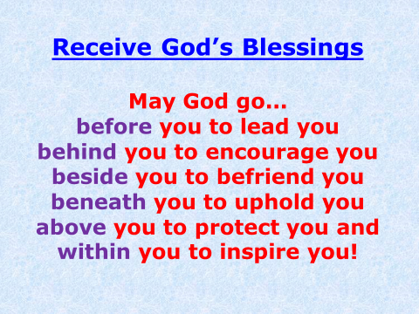
Amen!

