Youth Devotion – October 22, 2019
The Good Samaritan – Luke 10:25-37
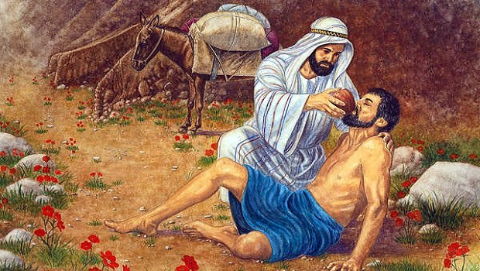
(Begin your devotion time with a prayer)
(Have a one or two students read the Bible verse aloud)
And behold, a lawyer stood up to put him to the test, saying, "Teacher, what shall I do to inherit eternal life?" He said to him, "What is written in the Law? How do you read it?" And he answered, "You shall love the Lord your God with all your heart and with all your soul and with all your strength and with all your mind, and your neighbor as yourself." And he said to him, "You have answered correctly; do this, and you will live."
But he, desiring to justify himself, said to Jesus, "And who is my neighbor?" Jesus replied, "A man was going down from Jerusalem to Jericho, and he fell among robbers, who stripped him and beat him and departed, leaving him half dead. Now by chance, a priest was going down that road, and when he saw him, he passed by on the other side. So likewise a Levite, when he came to the place and saw him, passed by on the other side. But a Samaritan, as he journeyed, came to where he was, and when he saw him, he had compassion. He went to him and bound up his wounds, pouring on oil and wine. Then he set him on his own animal and brought him to an inn and took care of him. And the next day he took out two denarii and gave them to the innkeeper, saying, 'Take care of him, and whatever more you spend, I will repay you when I come back.' Which of these three, do you think, proved to be a neighbor to the man who fell among the robbers?" He said, "The one who showed him mercy." And Jesus said to him, "You go, and do likewise."

(As you go through the questions and answers with your students, emphasize how the story of the Good Samaritan, reinforces what Jesus discussed with the lawyer who asked Him questions … Everyone is our neighbor, no matter who it is, no matter their race, creed or color, and yes, even their political views. In Christ’s eyes, we are all brothers and sisters.)
Discussion Questions
- Why do you think the people who passed by and neglected to help the injured man had the attitude they did?
- Are there people in your life, or that you’ve encountered in life that are like the priest and the Levite?
- Why do you think the Good Samaritan was willing to help the injured man?
- The Good Samaritan went the extra mile. He did more than just help the injured man on the road. What else did he do?
- What did the Samaritan receive for His trouble?
- Consider for a moment, the kind of friend you are to those in your life. Are you like or unlike the Good Samaritan? If you’re not like him, what changes can you make in your life to make yourself more like him?
Hopefully, you all remember something Jesus said. He said, “The Son of Man came to serve, not to be served.” Jesus did and does place other's needs first, and He expects us to do the same thing.
We live in a society that “preaches,” things like, “Me First,” and “You’re the most important person in your life.” None of that is true. Put others first. Jesus put the needs of mankind ahead of His own and gave the ultimate sacrifice, His life for our salvation. Perhaps, making others more important than ourselves isn’t such a bad idea.
(Close your devotion time with prayer)

