Youth/Student Devotion – 11/6/2019
Luke 17:11-19 – The Ten Lepers
(Open your devotion time in prayer)
(Have one of your students read the bible passage aloud)
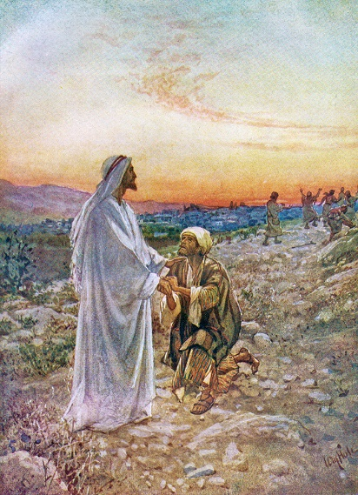
“On the way to Jerusalem, he was passing along between Samaria and Galilee. And as he entered a village, he was met by ten lepers, who stood at a distance and lifted up their voices, saying, "Jesus, Master, have mercy on us." When he saw them he said to them, "Go and show yourselves to the priests." And as they went they were cleansed. Then one of them, when he saw that he was healed, turned back, praising God with a loud voice; and he fell on his face at Jesus' feet, giving him thanks. Now he was a Samaritan. Then Jesus answered, "Were not ten cleansed? Where are the nine? Was no one found to return and give praise to God except this foreigner?" And he said to him, "Rise and go your way; your faith has made you well."

I guess the first question should be is, “What is Leprosy?” Take out your phones and look up information on leprosy.
(Have several students give definitions and meanings of Leprosy that they found.)

- Why do you think only one Leper came back to thank Jesus? (Answers will be based on the information the students have.)
In Chapter 5 of Luke, Jesus healed an individual Leper. Now in chapter 17, ten lepers approached him and asked to be healed.
2. When were the 10 Lepers healed?
You’ll notice the passage says, “As they went, they were cleansed.” That means they were cleansed of leprosy on their way to show themselves to the priests.
- The one healed leper who returned and praised Jesus was a Samaritan. Interestingly enough, it is presumed that the other nine were Jews,
  - Why do you think the other nine, especially if they were Jews, didn’t come back to thank and praise Jesus?
We see it in the story of the woman at the well, in the story of the Good Samaritan, and once again in these passages about the lepers. Jesus was giving His disciples a learning experience.
When people respond to the message of the Gospel of Jesus Christ, barriers are broken, racial, social, even gender (women were very sub-servant to men back in Jesus’ day).

- The Samaritan leper came back and thanked Jesus. Why is it important to thank God/Jesus? Why is it important to thank others for the things they do for us?
- Jesus healed ten lepers. Has Jesus ever healed you? Is there any healing you need in your life right now? If yes, have you asked Jesus for help?
Two words, Thank You. They’re not that hard to say. It should never be too hard to thank Jesus for everything He has done, does today, and will do in the future for us, especially the fact that He died on the cross for you and me.
Don’t hesitate. Thank Him (Jesus), thank others, and never be afraid to ask for help and healing. Amen
(Close your devotion time with a prayer)

