Red Letter Youth Bible Study – September 24, 2019
“You’ve got a Friend” – John 15:13; Matthew 11:28-30



(Begin your Bible study with the entire group saying the Opening Blessing aloud and making the sign of the cross.)

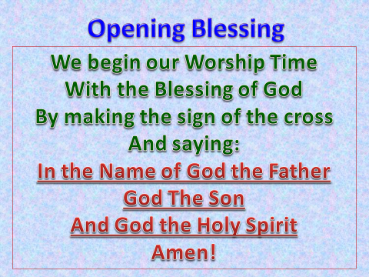

(Two to three times a year I would hold a “Bring a Friend” night. Although I always encouraged my students to bring a friend to youth night, I put a particular emphasis on it during this special youth night. I would make the theme friendship, and any friends who attended were invited to come to the following week’s fellowship event, i.e. bowling, movies, etc. at no charge.
It was always essential to make the visitors comfortable and put them on the spot. I rarely if ever called on one of them to read a verse or lead a prayer unless they volunteered.)
A great song to open up with after the blessings would be James Taylor’s, “You Got a Friend.” https://youtu.be/3WJ1cf3nrLE.

(Ask a student to read the 1st Bible verse)
“Come to me, all you who are weary and burdened, and I will give you rest. Take my yoke upon you and learn from me, for I am gentle and humble in heart, and you will find rest for your souls. For my yoke is easy, and my burden is light.” Matthew 11:28-30 (NIV)

Questions
- Who are the weary and burdened?
  - (The weary and the burdened are the ones Jesus reveals to His Father. They are the same people Jesus described as the poor in spirit, the meek, and those who hunger and thirst for righteousness.)

- What kind of rest is Jesus talking about?
  - (Jesus is talking about rest and relief from the burdens of our acknowledged sins. Once we realize how sinful we are sometimes, it’s more than we can bear. From our friend Jesus rest is a gift, “I will give you rest.” *
- What is a yoke? What is Jesus saying when He states, “My yoke is easy and my burden light? *
  - (The yoke is us taking on the Christian life and hope Christ gives us. Once we become a follower of Christ and live a Christian life, following God’s laws, living a Godly life, Spreading the Good News of the Gospel, is not a burden, but for us, it should be a joyous way to express our thanks to God for His undeserved Grace.) *
*(Parts of the answers are taken from, The Peoples Bible Commentary, Matthew, G.J. Albrecht, and M.J. Albrecht.)

What are some of the qualities you look for in a friend? (Answers will vary)
Let’s read the next Bible verse together and see what Jesus considers to be an essential quality in a friend.

"This is my commandment that you love one another as I have loved you. Greater love has no one than this that someone lay down his life for his friends. You are my friends if you do what I command you.
John 15:12-14 (ESV)

Okay, let’s take this verse apart one line at a time.
Jesus tells us to love one another as I have loved you. This ties in directly to the question Jesus was asked, “What is the greatest commandment?”
Love the Lord your God, with all of your heart, mind, soul, and spirit, and love your neighbor as yourself. Jesus never changes, He’s telling us the same thing in the verse from John, love, and love is the most important thing.
And then Jesus gives us a foretaste of what is to come. “Greater love has no one than this that someone lay down his life for his friends.” Yes, Jesus is saying putting others safety, and well-being first is very important. He is also saying, I’m going to be giving up my life for you shortly, why? Because you are my friends, and I love you.
Do as He commands? This is a no brainer. Love God, Love man. That’s it. God loves us so much that He sent us His Son, who is our friend, who loves us so much that He gave His life up for us, so we could live eternally.
Amen!
Prayer Time – 3 Words at a time
Today have your students and adult helpers stand in a circle, to build a prayer, three (3) words at a time. Being with one student say three words of a prayer, (Dear Lord I, or Heavenly Father we … etc.), then each student will add three words. If they come to the end of a sentence, then the next student will begin a new sentence with three words, until all of the students and adults have added three words. I usually made myself last, and my job was to add three words to the prayer, with the last one being, Amen.

Closing Blessings
Have all of the students stand and face you as you lead them in the final blessing using hand motions (self - explanatory from the words used)

