Red Letter
Youth Bible Study
September 3, 2019
Matthew 25:4-7; Ephesians 6:10-20
“The Whole Armor of God”

(Begin your Bible Study with the Opening Blessing. Have students say the Blessing together while making the sign of the cross.”
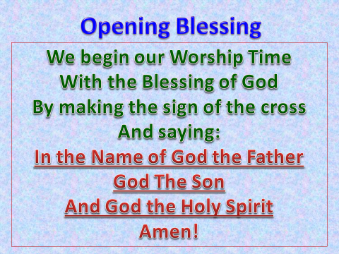
(Have a student read the Bible verse from Ephesians aloud)
”Finally, be strong in the Lord and in his mighty power. Put on the full armor of God, so that you can take your stand against the devil’s schemes. For our struggle is not against flesh and blood, but against the rulers, against the authorities, against the powers of this dark world and against the spiritual forces of evil in the heavenly realms. Therefore put on the full armor of God, so that when the day of evil comes, you may be able to stand your ground, and after you have done everything, to stand. Stand firm then, with the belt of truth buckled around your waist, with the breastplate of righteousness in place, and with your feet fitted with the readiness that comes from the gospel of peace. In addition to all this, take up the shield of faith, with which you can extinguish all the flaming arrows of the evil one. Take the helmet of salvation and the sword of the Spirit, which is the word of God.
And pray in the Spirit on all occasions with all kinds of prayers and requests. With this in mind, be alert and always keep on praying for all the Lord’s people. Pray also for me, that whenever I speak, words may be given me so that I will fearlessly make known the mystery of the gospel, for which I am an ambassador in chains. Pray that I may declare it fearlessly, as I should.”

(We’ve all read and heard the passage from Ephesians before. Paul is telling us to defend ourselves from the evil one, the devil. Satan is continually trying to make our lives miserable, and we need to protect ourselves against all of his efforts. So today, let’s take some time to dig into the meaning of putting on, “The Full Armor of God”)

Belt of Truth: John 8:31-32 “To the Jews who had believed him, Jesus said, “If you hold to my teaching, you are really my disciples. Then you will know the truth, and the truth will set you free.”
(Jesus is the way, the truth, and the light. The belt of truth is believing in Jesus, having Faith in what He has done for us through His death and resurrection. Because of His promise to us in Matthew 28, “And surely I will be with you always,” that He truly is by our sides to help, love and protect us.)

Breastplate of righteousness:

What purpose does a breastplate serve?

The breastplate was a central part of the Roman soldier's armor—it provided protection for the torso, which contains vital organs like the heart, lungs, and so on. Without a breastplate, a soldier would be asking for death, as any attack could instantly become fatal. With a sturdy breastplate, the very same attacks become ineffective and useless, as blows glance off the armor.

Proverbs 11:4
“Riches do not profit in the day of wrath, but righteousness delivers from death.”

Without righteousness, we leave ourselves open to almost certain death. With righteousness—just as with a breastplate—the otherwise fatal attacks of our enemy are thwarted.

Feet fitted with the readiness that comes from the gospel of peace

Romans 10:15 (New International Version)
¹⁵ And how can anyone preach unless they are sent? As it is written: “How beautiful are the feet of those who bring good news!”

(We need to be reading the bible, understanding its meaning, so we can bring the Good News of Jesus Christ to others.)

Shield of Faith

Hebrews 11:1-2 (New International Version)

Faith in Action
“Now, faith is confidence in what we hope for and assurance about what we do not see. This is what the ancients were commended for.”

(Our belief, our Faith is based on believing in what we don’t see, not on seeing what we believe. Remember the disciple, Thomas? He would not believe Jesus had risen from the dead until he put his hands in Jesus’ wounds. After Thomas did finally see Jesus, Jesus said, “You believe because you see, blessed are those who believe without seeing.”)
Helmet of Salvation

Romans 1:16-17 (New International Version)
“For I am not ashamed of the gospel, because it is the power of God that brings salvation to everyone who believes: first to the Jew, then to the Gentile. For in the gospel, the righteousness of God is revealed—a righteousness that is by faith from first to last, just as it is written: “The righteous will live by faith.”

Sword of the Spirit

Hebrews 4:12-13 (New International Version)

“For the word of God is alive and active. Sharper than any double-edged sword, it penetrates even to dividing soul and spirit, joints and marrow; it judges the thoughts and attitudes of the heart. Nothing in all creation is hidden from God’s sight. Everything is uncovered and laid bare before the eyes of him to whom we must give account.”

(God is omnipresent, He sees, and knows everything, even what is in your heart!)

God’s protection, God’s armor comes from Faith. He loves us. He gave us His Son Jesus as a living sacrifice for our sins. He sent His Holy Spirit to guide us and instruct us throughout our lives. God provides us with the power of His armor to protect us during our lifetime from the evil one.

Prayer Time

Have the student stand in a circle for a time of building a prayer together. Choose one student to say four (4) words. (Example: Dear Lord, thank you, or Dear Lord Heavenly Faith.) The next student adds on four more words until everyone in the circle has added four words of prayer, including adults. The students may end a sentence, and the next student can begin a new one. The tricky part, the last person (usually the leader), tries to say four words, with the last word being, “Amen.”

Closing Blessing

Have all students remain standing and turn facing you, the leader, as you lead them in the hand motions of the closing blessing. This is pretty straightforward, before you – hand in front of you, above you – hands over your head, etc.

