Red Letter Youth Bible Study – September 17, 2019
“The Sheep and the Goats” – Matthew: 25:31-46

(Begin your Bible study with the entire group saying the Opening Blessing aloud and making the sign of the cross.)
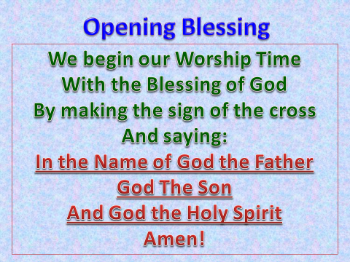

The final judgment. Yes there will be on. Jesus will return with His angels. Some will be saved, some will not. The passage you’re about to read is a bit of a “sticky wicket.” That is, on the surface it seems to go against everything we’ve been taught about salvation and eternal life. We’re taught, B.G.T.F., By Grace, Through Faith. That’s how we are saved. God’s undeserved Grace (love) for us through the sacrifice of His Son Jesus Christ, and our Faith, our belief in Jesus and what He did for us by dying on the cross and rising from the dead three days later.
But this passage from Matthew that talks about the final judgment talks mainly about good works, not our sins, not our faith per se, but good works. So let’s read it and then delve into it a bit.

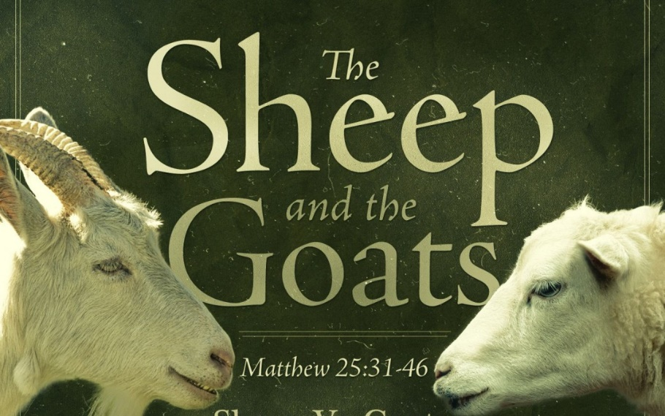

The Final Judgment
"When the Son of Man comes in his glory, and all the angels with him, then he will sit on his glorious throne. Before him will be gathered all the nations, and he will separate people one from another as a shepherd separates the sheep from the goats. And he will place the sheep on his right, but the goats on the left. Then the King will say to those on his right, 'Come, you who are blessed by my Father, inherit the kingdom prepared for you from the foundation of the world. For I was hungry, and you gave me food, I was thirsty, and you gave me drink, I was a stranger, and you welcomed me, I was naked, and you clothed me, I was sick, and you visited me, I was in prison, and you came to me.' Then the righteous will answer him, saying, 'Lord, when did we see you hungry and feed you, or thirsty and give you drink? And when did we see you a stranger and welcome you, or naked and clothe you? And when did we see you sick or in prison and visit you?' And the King will answer them, 'Truly, I say to you, as you did it to one of the least of these my brothers, you did it to me.'
"Then he will say to those on his left, 'Depart from me, you cursed, into the eternal fire prepared for the devil and his angels. For I was hungry, and you gave me no food, I was thirsty, and you gave me no drink, I was a stranger, and you did not welcome me, naked and you did not clothe me, sick and in prison, and you did not visit me.' Then they also will answer, saying, 'Lord, when did we see you hungry or thirsty or a stranger or naked or sick or in prison, and did not minister to you?' Then he will answer them, saying, 'Truly, I say to you, as you did not do it to one of the least of these, you did not do it to me.' And these will go away into eternal punishment, but the righteous into eternal life."

Discussion Questions
- What are the criteria Jesus uses for who is a sheep and who is a goat? (Jesus about feeding the hungry, showing hospitality to strangers, clothing the naked (needy), and visiting the sick and those in jail. Jesus is precise about His expectations of us.)

- As you go through your daily life, who today are the hungry, thirsty, strangers, naked, sick, and imprisoned?

Good works are not the cause of salvation, but they are an inevitable consequence. When a person is in a right relationship with God they will do good works, because this is the purpose of their salvation.
Take a minute to read Ephesians 2:8-10
For by grace, you have been saved through faith. And this is not your own doing; it is the gift of God, not a result of works, so that no one may boast. For we are his workmanship, created in Christ Jesus for good works, which God prepared beforehand, that we should walk in them.

- What do verses 8-9 say about how we are saved?

- Verse 10 states why we were created. Why is that?

Now take a minute to read James 2:14-17
Faith without Works Is Dead
“What good is it, my brothers, if someone says he has faith but does not have works? Can that faith save him? If a brother or sister is poorly clothed and lacking in daily food, and one of you says to them, "Go in peace, be warmed and filled," without giving them the things needed for the body, what good is that? So also faith by itself, if it does not have works, is dead.”

- James is reiterating what Jesus says in the Matthew passage, mentioning not helping the needy, like the poorly clothed and lacking food. What does this tell you about how Faith and Works are tied together?
- At this point in your life, who do you feel you identify with more, The Sheep or the Goats?

God wants everyone to be saved and live in eternity with him, 1 Timothy 2:4. Have Faith in Jesus, and be a servant to all just like He was and is.
Amen
Prayer Time
(Today, ask one of your students to close your Bible study in prayer, followed by the Lord’s Prayer said by all)

The Final Blessing
(Have all the students stand up and face you, the leader as you lead them in the Closing Blessings, using the hand motions.)

