Red Letter – Youth Bible Study
September 10, 2019
What Stresses You Out?
Matthew 6:25-34

(Begin your Bible Study with the Opening Blessing. Have students say the Blessing together while making the sign of the cross.”

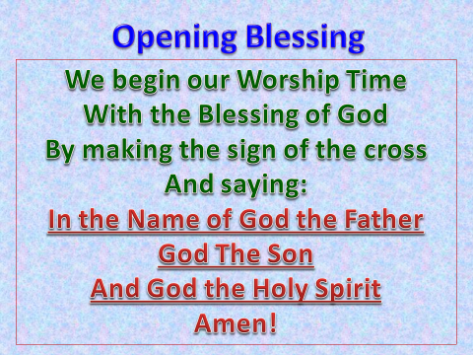

We all have things that stress us out. Stress may come from a relationship you’re in, or perhaps your job, school, family, or maybe even someone at church.
- What’s your number one stressor?
- How do you handle the stress that this person or situation causes you?

During His Sermon on the Mount, Jesus taught and spoke on a variety of things. He talked about prayer, giving to the needy, anger, lust, and even divorce. Although prayer is probably one of the most notable things He spoke of (He introduced what we now call The Lord’s Prayer during His sermon), another item He goes into detail about is, “Worry.” Most of you have probably heard all or part of this passage before. Could I please have a volunteer to read it aloud?

"Therefore I tell you, do not be anxious about your life, what you will eat or what you will drink, nor about your body, what you will put on. Is not life more than food, and the body more than clothing? Look at the birds of the air: they neither sow nor reap nor gather into barns, and yet your heavenly Father feeds them. Are you not of more value than they? And which of you by being anxious can add a single hour to his span of life? And why are you anxious about clothing? Consider the lilies of the field, how they grow: they neither toil nor spin, yet I tell you, even Solomon in all his glory was not arrayed like one of these. But if God so clothes the grass of the field, which today is alive and tomorrow is thrown into the oven, will he not much more clothe you, O you of little faith? Therefore do not be anxious, saying, 'What shall we eat?' or 'What shall we drink?' or 'What shall we wear?' For the Gentiles seek, after all these things, and your heavenly Father knows that you need them all. But seek first the kingdom of God and his righteousness, and all these things will be added to you.
"Therefore do not be anxious about tomorrow, for tomorrow will be anxious for itself. Sufficient for the day is its own trouble.”

(Have a whiteboard or newsprint ready for this next part)
There’s a lot of information packed into those few verses, aren’t there? Let’s take a moment, and I’d like everyone to re-read the passage to yourself.
- What is one thing in the passage that really spoke to you? What really stood out and grabbed your attention?
- What won’t being stressed out over things do for you according to the passage? (It won’t add one hour to your life, actually stress is proven to shorten our lives, or even kill people.)
- Jesus says that your basic needs will be taken care of. What are your basic needs? (Food, clothing, shelter, and in today’s world, healthcare.)
- What does Jesus say we should focus on? (Righteousness)
- Jesus also says, don’t worry about tomorrow, you have enough problems right here and now today.
  - Can you change the past?
  - Can you change the future (We really don’t know because it’s all part of God’s plan isn’t it? The answer would be, NO!)
  - Can you change the now? (Yes you can (Well Jesus can), by being right with God, and through prayer. God does listen to our petitions and will answer them, if they fit into His plan, in His time, not ours.)

Small-Group Prayer Time
(Put the students and adults in small groups, 3-4 people per (Circles) group. As one person in each group to talk about (No more than a minute) what stresses them out and or what they worry about. Beginning with the person to the left of the one who just spoke, each person now prays for that person until they go full circle. Now, the next person does the same thing. Talking about their stresses and problems, followed by prayer from each person in the group. Continue this in each group until everyone has spoken and has been prayed for. When all groups are done, lead everyone in the Lord’s Prayer.)

Closing Blessing

(Have all of the students and adults stand facing you (the leader), and say the closing Blessings with you using the hand-motion, (Before you – hands in front of you, behind you – hands behind you, etc.)

