Red Letter Youth Bible Study
August 27, 2019
“There is no “I” in team.”

(There are some really great songs, yes secular too, to introduce this Bible study. I used a song by the Beatles, “With a little help from my friends.” It’s an easy song to find on youtube.)

(Have the students stand for the opening blessing, everyone saying it together, and making the sign of the cross)

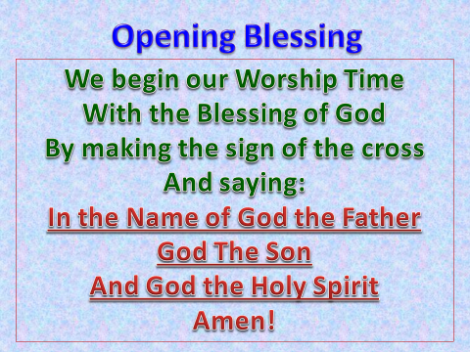
(There is an excellent video on Youtube of the Minions changing a light bulb, you may want to include here. https://youtu.be/UdZ9P_tWFSw)

(Have students look up the Bible verse 1 Corinthians 12:12-30, have two or three students take turns reading it aloud.)

“For just as the body is one and has many members, and all the members of the body, though many, are one body, so it is with Christ. For in one Spirit, we were all baptized into one body—Jews or Greeks, slaves or free—and all were made to drink of one Spirit.
For the body does not consist of one member but of many. If the foot should say, "Because I am not a hand, I do not belong to the body," that would not make it any less a part of the body. And if the ear should say, "Because I am not an eye, I do not belong to the body," that would not make it any less a part of the body. If the whole body were an eye, where would be the sense of hearing? If the whole body were an ear, where would be the sense of smell? But as it is, God arranged the members in the body, each one of them, as he chose. If all were a single member, where would the body be? As it is, there are many parts, yet one body.
The eye cannot say to the hand, "I have no need of you," nor again the head to the feet, "I have no need of you." On the contrary, the parts of the body that seem to be weaker are indispensable, and on those parts of the body that we think less honorable we bestow the greater honor, and our unpresentable parts are treated with greater modesty, which our more presentable parts do not require. But God has so composed the body, giving greater honor to the part that lacked it, that there may be no division in the body, but that the members may have the same care for one another. If one member suffers, all suffer together; if one member is honored, all rejoice together.
Now you are the body of Christ and individually members of it. And God has appointed in the church first apostles, second prophets, third teachers, then miracles, then gifts of healing, helping, administrating, and various kinds of tongues. Are all apostles? Are all prophets? Are all teachers? Do all work miracles? Do all possess gifts of healing? Do all speak with tongues? Do all interpret? But earnestly desire the higher gifts.
And I will show you a still more excellent way.”

There is no “I” in team

Discussion questions
- How well did the Minions in the video work together? Why weren’t they able to accomplish their goal of changing a lightbulb properly?
- What are some teams you can think of, that would not function well at all if everyone on the team didn’t work together? (Baseball, football, hockey, soccer, etc.)
- In our Bible passage from 1st Corinthians we just read, Paul talks about our physical body and how it works together to function correctly. What are some of the things are body must do to work correctly?
- The description that Paul gives of our physical body working together in unison, as a team, is an analogy for how the Body of Christ (We as Christians) should work together.
  - Give some examples of how we as Christians can work together.
- Paul also talks about how we all have unique gifts given to us by God. How should we be using these gifts?
(As Christians, we need each other. We need to work together as a team, using our gifts to help each other, and bring others into the Body of Christ. There is no “I” in team. Yes we are individuals. Yet as individuals with individual gifts, God expects up to come together, to work together, and share His goals with others.)

His goals? Jesus states His goals pretty clearly in Matthew 28:18-20,
"All authority in heaven and on earth has been given to me. Go therefore and make disciples of all nations, baptizing them in the name of the Father and of the Son and of the Holy Spirit, teaching them to observe all that I have commanded you. And behold, I am with you always, to the end of the age."

And remember the most important thing of all. Jesus is a member of our team. He says it in the Matthew passage. “And behold, I am with you always, to the end of the age.”
Not an awful person to have as a part of your team, is it?
Amen
(As the Lord’s Prayer is generally a group prayer, use it as your closing prayer today.”
Our Father who art in heaven,
hallowed be thy name,
thy kingdom come,
thy will be done on earth as it is in heaven.
Give us this day our daily bread;
and forgive us our trespasses
as we forgive those
who trespass against us;
and lead us not into temptation,
but deliver us from evil.
For thine is the kingdom
and the power and the glory
forever and ever. Amen

(Close your Bible study time with the blessings below, using appropriate hand motions. Have students stand and face you .. the leader)



