Jesus Calms the Storm - Mark 4:35-41 (ESV)
Youth Devotion - September 10, 2019
(The story of Jesus calming the storm is also written in Matthew 8:18, 23-27, and Luke 8:22:25)
Open your devotion time with prayer
Have a student read the Bible passage aloud
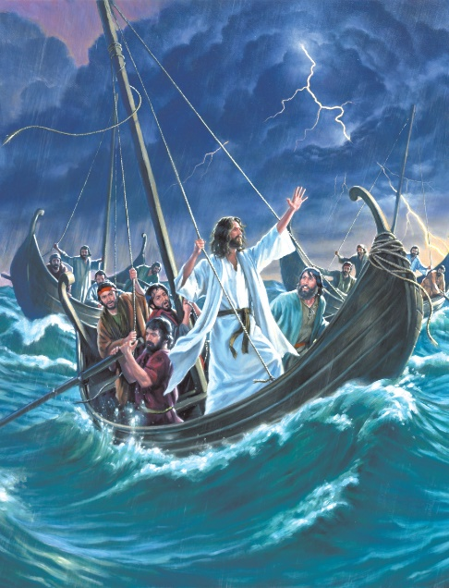
On that day, when evening had come, he said to them, "Let us go across to the other side." And leaving the crowd, they took him with them in the boat, just as he was. And other boats were with him. And a great windstorm arose, and the waves were breaking into the boat so that the boat was already filling. But he was in the stern, asleep on the cushion. And they woke him and said to him, "Teacher, do you not care that we are perishing?" 39And he awoke and rebuked the wind and said to the sea, "Peace! Be still!" And the wind ceased, and there was a great calm. He said to them, "Why are you so afraid? Have you still no faith?" And they were filled with great fear and said to one another, "Who then is this, that even the wind and the sea obey him?"
The Sea of Galilee, which is surrounded by high hills, is subject to sudden storms. In this story, we find Jesus sleeping on a cushion at the back of the boat when the storm comes up (Yes Jesus slept, he as human and God).
This must have been one heck of a storm! Many of Jesus’ followers were fishermen. They would have been used to bad weather, waves hitting their fishing boats and heavy rains. So, if these fishermen were panicking, then this must have been a massive storm. So large, so intense, that they feared for their lives.
They knew Jesus was a prophet, that He could perform miracles, yet, the disciple's Faith must have been a little lacking don’t you think? If they believed Jesus to be the Son of God, what were they worried about?
Discussion Questions
- Imagine for a moment you were on the boat. Perhaps you are one of the disciples, or maybe you’re the boat pilot. What would you have done when the storm came up?

- The disciples wake Jesus up from his restful sleep. What was Jesus’ reaction to how they were acting?

- What kind of Faith did the disciples have in this situation?

- What do you do when a storm comes up in your life? Do you panic? Do you pray about it?

- What’s the most stressful storm you’ve ever had in your life? How did you handle it?

Sometimes our Faith does get weak, doesn’t it? We feel like there’s no way out, through or over our problems.
Remember this: Christ is with you always, till the very end of the day. After Jesus returned to heaven, He sent us the “counselor.” Who was that?
The Counselor is God’s Holy Spirit. He guides us and gives us direction during life’s storm. The Holy Spirit helps us to stay on the path God has chosen for us. If you have a storm in your life you can’t handle, ask God’s Holy Spirit to guide you through the storm. He’s there for you. Amen.
Close your devotion time with prayer

