Red Letter
Youth Bible Study
August 6, 2019
Are you a Minion for Christ?

(Begin your Bible study with this opening blessing, with everyone saying it together.)
We begin our Worship Time with the Blessing of God by making the sign of the cross and saying:
In the Name of God the Father, God the Son, and God the Holy Spirit. Amen

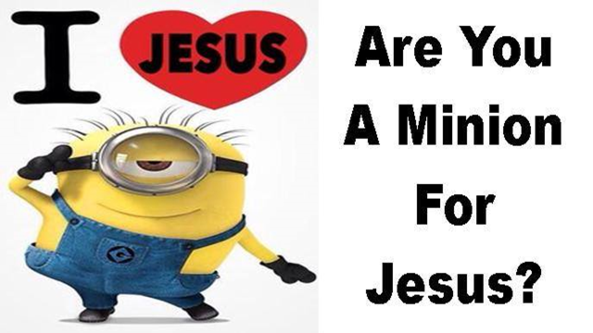

What is a Minion anyway?
Everyone take out your phone and Google the word Minion.
(Give the group a moment, now have them give answers to what they found, while you or a student write them out on newsprint or whiteboard)

(After they have given you some answers to the definition, add these if they didn’t mention them.)
1. A servile follower or subordinate of a person in power.
2. A favored or highly regarded person
Servile – Abjectly submissive; slavish
(Have a student read the Bible verse aloud)
Bible Verse
1Corinthians 7:21-23
²¹ Were you a slave when you were called? Don’t let it trouble you—although if you can gain your freedom, do so. ²² For the one who was a slave when called to faith in the Lord is the Lord’s freed person; similarly, the one who was free when called is Christ’s slave.²³ You were bought at a price; do not become slaves of human beings.

Let’s break it down.
Remember, 2000 years ago, slavery was quite common. So in verse 21, Paul is literally speaking about/to people who are slaves.
What is he saying to them?
What does verse 22 say about positions in society and slavery?
(We are all quite literally slaves to Christ because He freed us from sin through His death on the cross, and the constraints of the Law that we can never keep perfectly)
Verse 23 has two parts.
How were you and I bought at a price?
Paul goes on to say, “Do not become slaves of humans.”
Although slavery is outlawed in our society, how can we become slaves to humans?
(Paul is telling us not to break God’s commandments to please men)
What are some ways we might break God’s commandment to please our fellow man?
(Lie, cheat, kill, steal, denounce we are Christians, don’t insist we have time from work for worship, etc.)

Christ bought our freedom from sin at a cost, His life for ours.
Greater love has no one than this: to lay down one’s life for one’s friends.
John 15:13 NIV

He did this out of love for us.
Now we are saved by faith because of His grace, His undeserved love for us.

Jesus expects us to follow His examples and be a servant to everyone. He expects us to listen and follow His words, the final command He gave the disciples before he left this world. Read them together with me from your Bible.
Matthew 28:18-20

Then Jesus came to them and said, “All authority in heaven and on earth has been given to me. Therefore go and make disciples of all nations, baptizing them in the name of the Father and of the Son and of the Holy Spirit, and teaching them to obey everything I have commanded you. And surely I am with you always, to the very end of the age.”

Those verses are quite a challenge for us, aren’t they? The question is, are you, Minion, enough to follow up on them and do what He commands?
Are you ready to “Go” and make disciples? Are you ready to spread the Gospel to everyone?
You can, because He, Jesus, is with you every step of the way.
Amen

Small-Group Prayer Time

Have students break up into groups of 3 or more. Have one student in each group talk about something troubling or bothering them. Then have the other students each pray for that student. Have each student in the group do the same, until all of them have prayed for each other.
When all of the groups are finished, lead the group in saying, The Lord’s Prayer together.

Closing Blessing

Have the group stand and face you. Lead them in this closing devotion, with the students saying it aloud with you and making the hand motions. (Simply using your hands, before you, behind you, beside you, beneath you, above you and within (pointing to chest) you.

Receive God’s Blessings

May God go...before you to lead you
behind you to encourage you
beside you to befriend you
beneath you to uphold you
above you to protect you and
within you to inspire you!

