Jesus’ Triumphal Entry
August 13, 2019

Jesus’ entry into Jerusalem shortly before He died is a story of expectations. The disciples had high expectations of Jesus after traveling with Him for three years. The people had high expectations of this profit and miracle worker if He was who He said He was. And the religious leaders had high expectations of Jesus too. They expected Him to live and preach within the parameters of the Law. Because He didn’t do this, they (the religious leaders – Pharisees) were admonishing Him at every turn. That with their jealousy of His following and concerns for their leadership roles brought them to a final confrontation with Jesus, that would lead to His death.

(Begin your time with students by leading them in prayer. Then have several of them read the Bible verse aloud.)
Luke 19:28-24 (ESV)
28And when he had said these things, he went on ahead, going up to Jerusalem. 29When he drew near to Bethphage and Bethany, at the mount that is called Olivet, he sent two of the disciples, 30saying, "Go into the village in front of you, where on entering you will find a colt tied, on which no one has ever yet sat. Untie it and bring it here. 31If anyone asks you, 'Why are you untying it?' you shall say this: 'The Lord has need of it.'" 32So those who were sent went away and found it just as he had told them. 33And as they were untying the colt, its owners said to them, "Why are you untying the colt?" 34And they said, "The Lord has need of it." 35And they brought it to Jesus, and throwing their cloaks on the colt, they set Jesus on it. 36And as he rode along, they spread their cloaks on the road. 37As he was drawing near—already on the way down the Mount of Olives—the whole multitude of his disciples began to rejoice and praise God with a loud voice for all the mighty works that they had seen, 38saying, "Blessed is the King who comes in the name of the Lord! Peace in heaven and glory in the highest!" 39And some of the Pharisees in the crowd said to him, "Teacher, rebuke your disciples." 40He answered, "I tell you, if these were silent, the very stones would cry out."
41And when he drew near and saw the city, he wept over it, 42saying, "Would that you, even you, had known on this day the things that make for peace! But now they are hidden from your eyes. 43For the days will come upon you, when your enemies will set up a barricade around you and surround you and hem you in on every side 44and tear you down to the ground, you and your children within you. And they will not leave one stone upon another in you, because you did not know the time of your visitation."

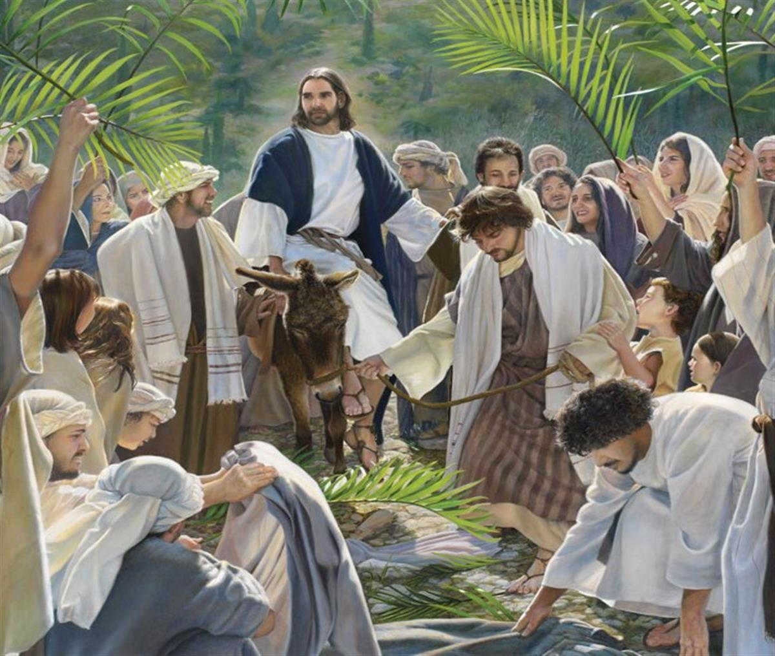

Discussion Questions

Why did Jesus make plans for what we call, “His triumphal entry,” into Jerusalem?

Why did the people rejoice and praise Jesus as He rode into Jerusalem?

The crowd was hoping for a soldier king who would wage war against Rome and defeat them. What kind of King was Jesus?

Oh, those Pharisees! Not only did they tell Jesus to rebuke his followers, but in doing so, they were rebuking Jesus, the Son of God. What was Jesus’ answer to them? Explain.

Without naming names, are their people in the church who remind you of the Pharisees? In your life?

In verses 41-45, Jesus wept over the city. What did He know that they didn’t?
(Have one of your student's close devotion time with a prayer)

